Water week I

Group 1: Yvonne Amgarten, Lara Blasco, Carmen Cambrils, Karen Louise Edland Gustavsen, Valeria Ritter, Selina Schmiedl

Date: Wednesday 16 February 2022

Place: Makrellbekken, Oslo

Purpose: There are two different perspectives on the purpose of this project. From the company's point of view, it is very good and helpful if they can work together with a university or a school class as we are making some useful research for them. On the other hand, there is the perspective from us, the students, who have a great role model to learn from and implement this later in their lessons. It is great for a class to be part of such an important project, and it also motivates to learn from the best. Another advantage for us as well as for our future school kids is that one can directly link theory and practice. In this way, the pupils have a direct connection in their brains between what they have experienced and their own senses. This causes a very good memory for most people. If you are a part of a project, elaborations and experiences are needed.

Equipment:

Name | Foto
1x water catcher (2m length) | 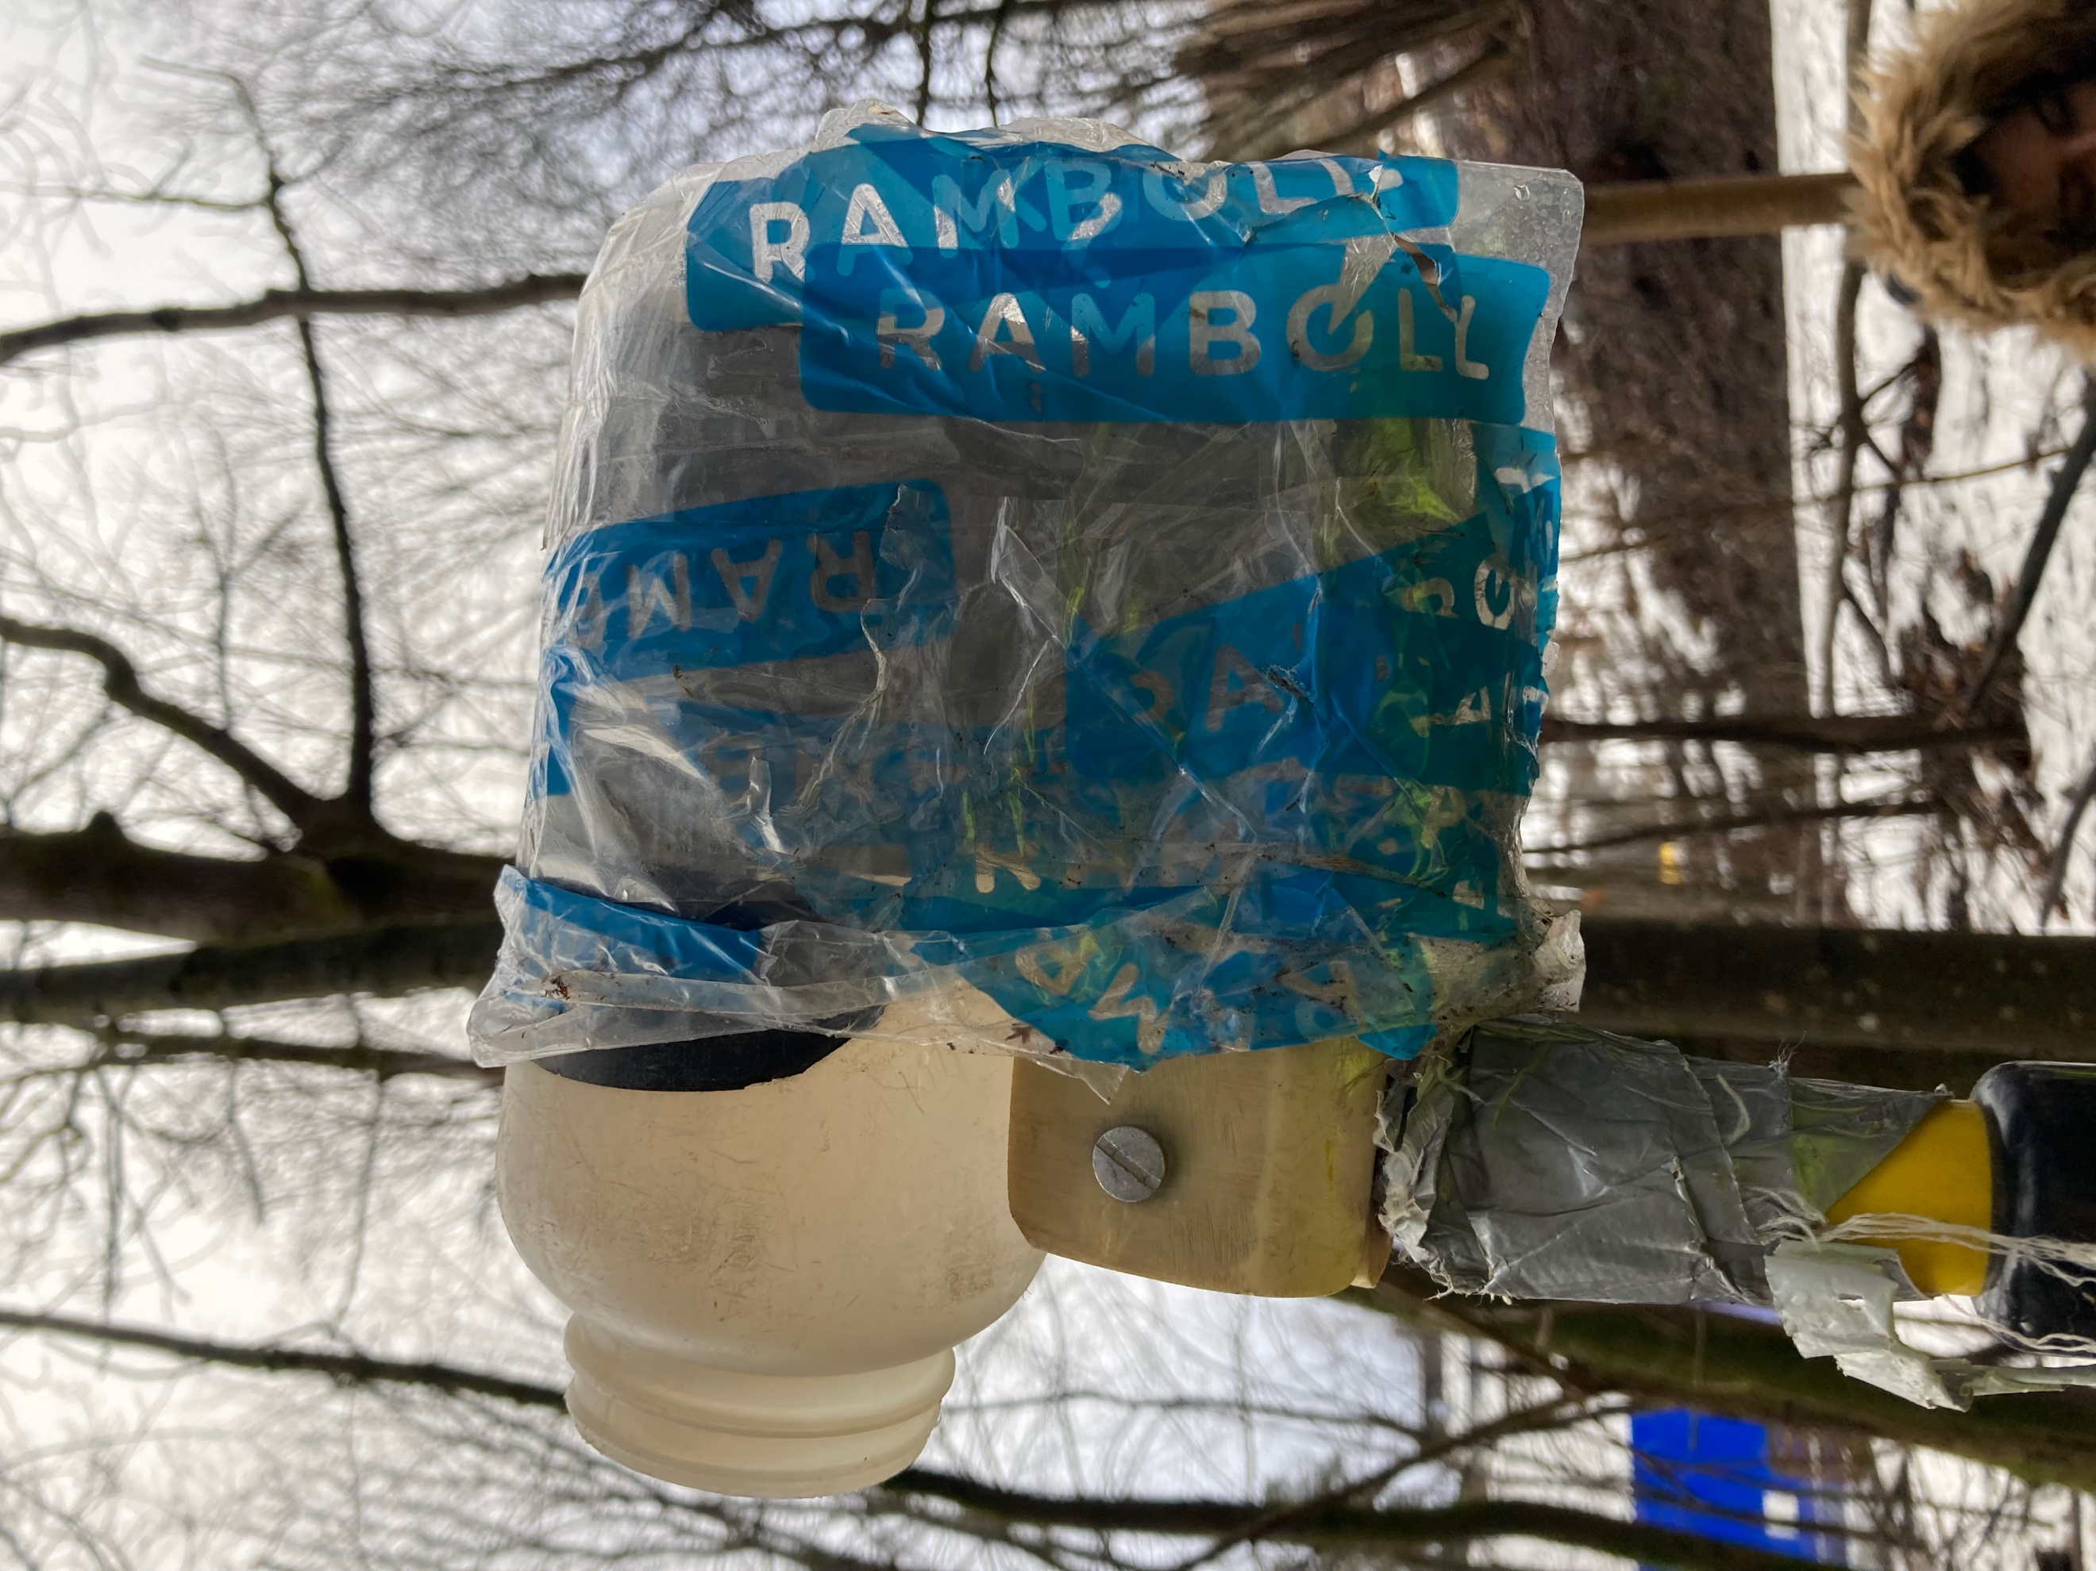  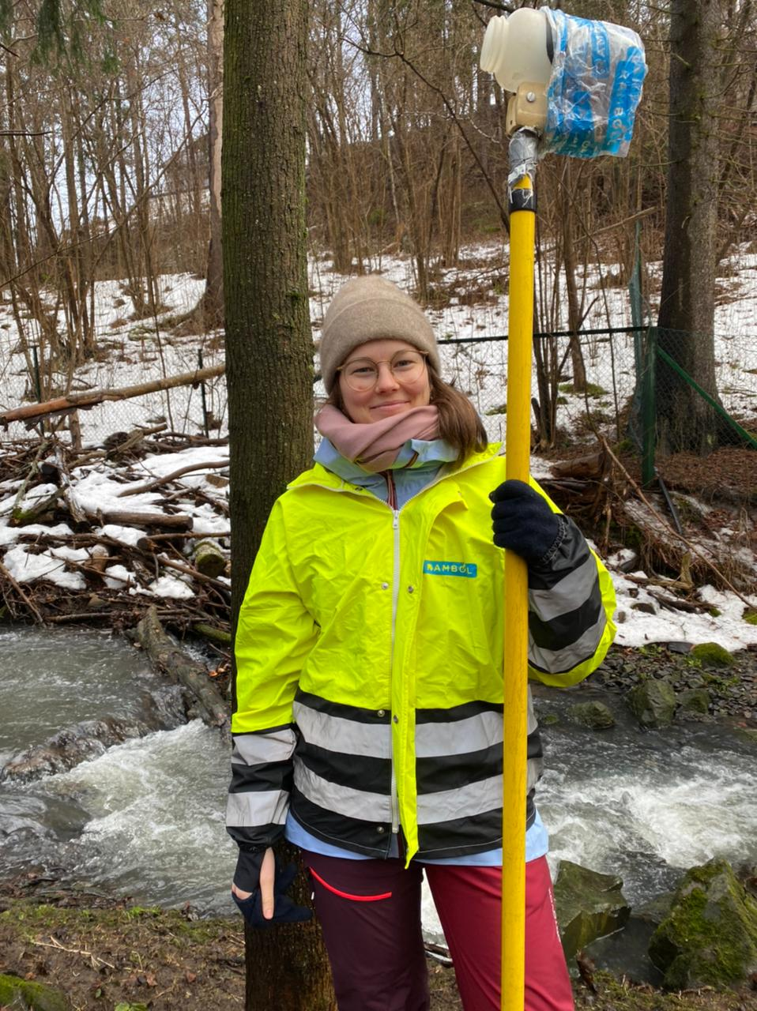
2x plastic bottles of each 2000ml | 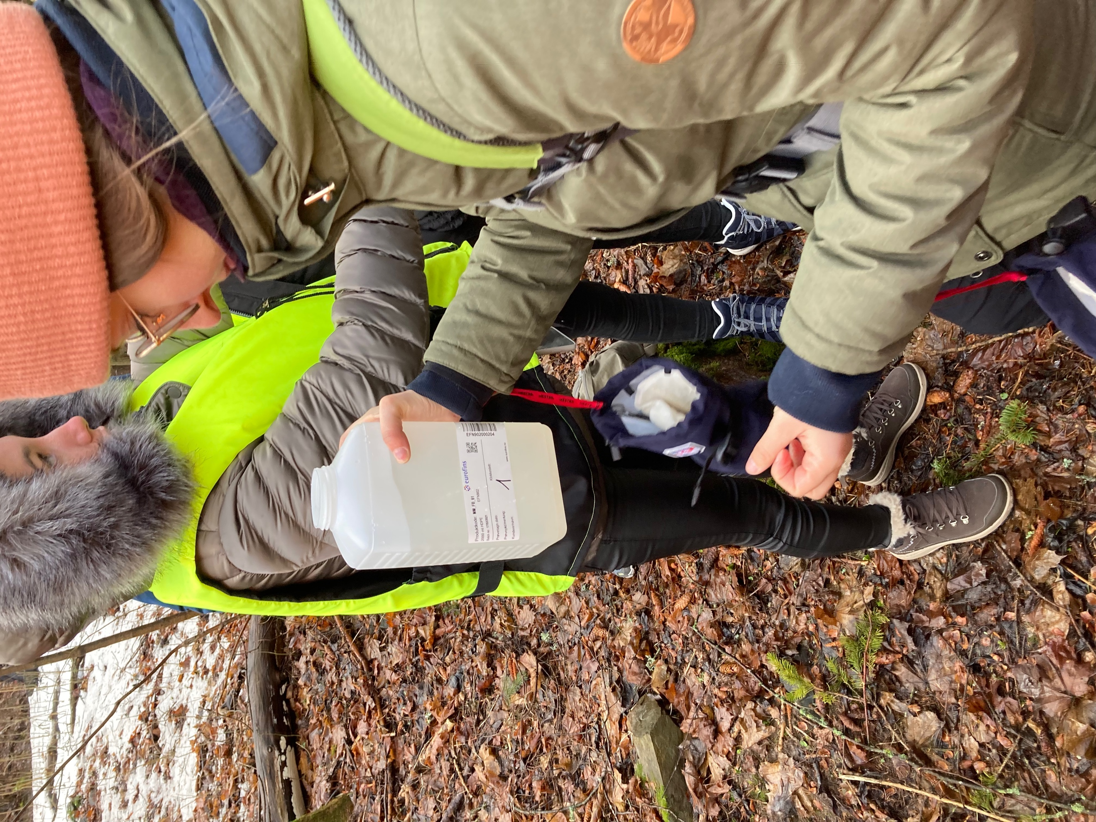
1x glass jar with 100ml acid (mercury) | 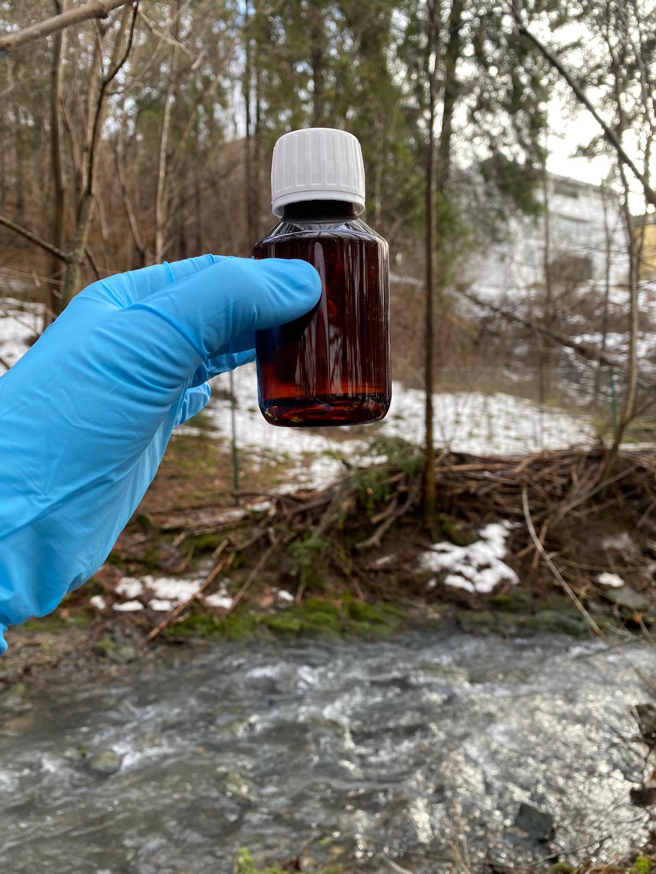
1x ysi exo turbitity sensor with display | 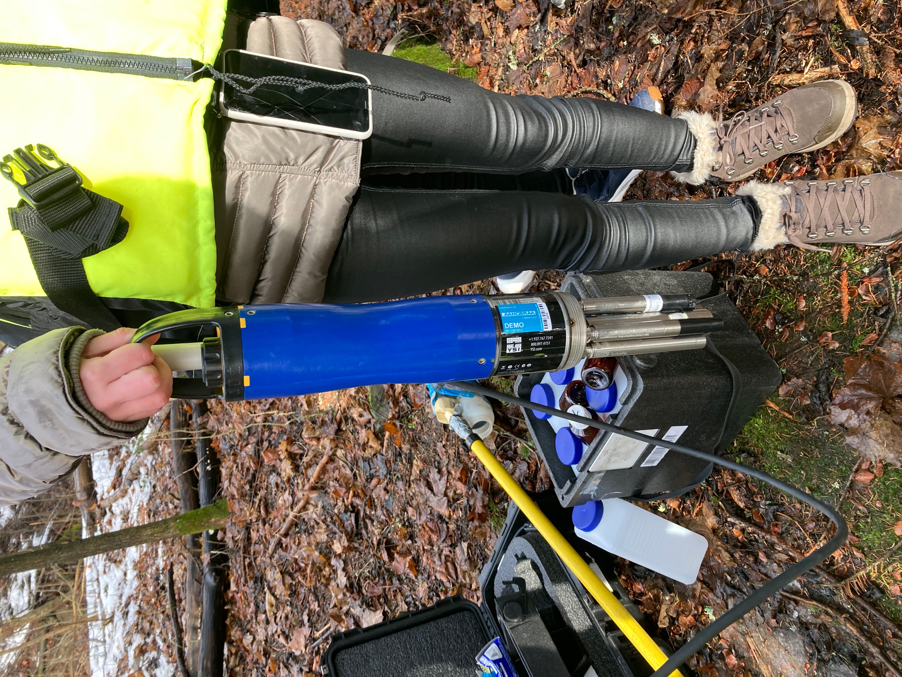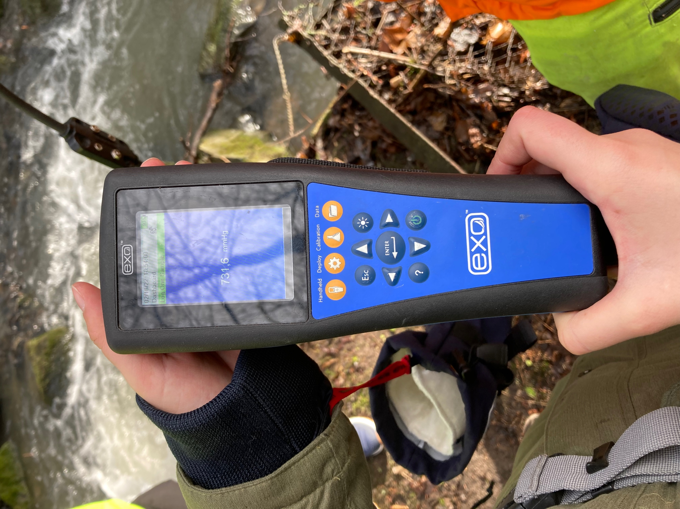

Fieldwork: It was a nice day, approximately 5 degrees and the sun came out when we had the kickstart on the cooperation project with Ramboll. In the upper stream there was a neutral smell. The color of the water was grey. The stream was fast this day because of the temperature affection. There was a little snow left and a lot of ice on the pavement. The rocks were covered with moss, and many twigs were laying around. It was a spruce tree and European aspen next to the river.

Group 1 started the fieldwork in the upper stream. In this river, all the water, from the “secret” tunnel comes. That is why we came to monitor. We must make sure nothing is affecting this river. We controlled the upstream and downstream, to see If the quality is good. And that it is not polluted or influenced of the work happening in the tunnel. Out in the sea they have automatic monitors checking the quality, but in small rivers like this, it is a better result if you do it manually.

With the help of our equipment, we can measure PH, salinity, and particles. And we measured heavy metal, with mercury. (See picture)

Results: After having extracted the water samples, Ramboll will analyze them in the laboratory.
With our class, we analyzed the PH value (PH indicates the acidity or alkalinity, in this case of a liquid such as water). We were able to test that the water had a PH of 5-6. In order to do this, we used a PH paper, which we help in the water for half a second. To be sure, we made two samples. In the first one we clearly saw that the water had a PH of 6. With the second we realized that it was between 5 and 6 PH.

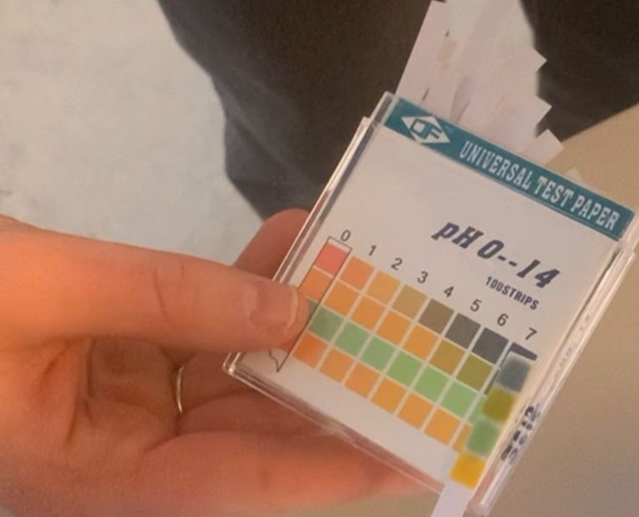
PH value

Discussion In this complex project, it has been a lot of concerns. Socially, political, and economical reasons. We will give some examples here and all the aspects.

Social aspects are all the people living around this area that have actual concerns about life because of this project. Some because they are afraid that they never can live in their house again as it may sink into the ground or get cracks in the walls. Others because of the highly trafficked working area now or their kids school way. Additionally, there are general concerns like dust or vibrations that roil the people.

Political aspects were complex since the beginning. There were lots of discissions to take that affected a lot of people. Due to the water project, other projects had to be put on hold. The price for the whole thing is increasing all the time. Now we speak of billions of kroners. However, the government would get a big fine if they would not do this. EU has pointed this out as Norwegians soft spot, so it had to be taken care of immediately. Not only because of the risk of terrorism. Algae could contaminate the water and the rinsing machine could break, so it is more than one reason for why this was decided as a must do project.

Economic aspects are that lots of projects need to be put on hold because of this huge city project. Due to the worried parents, they need to put up guards on their school way to make sure they have a safe way while they are doing this project. It is a huge system around this tunnel. When they were working on the entrance to the tunnel, they had to have two guys out in Holsfjorden monitoring the water for two weeks. This was to make sure it was not affected or contaminated by the work they do. Moreover, they also had to build a fence around the school, so the dust particles would not come into the school yard. If something would happen to people living around the working areas, the government must pay big money to cover up. The cost of this project is increasing all the time.

Sustainable thinking is all about seeing all points of view. In our situation we see it from a science and environmental point of view. We need sustainable water for everyone, guaranteed clean water. We use our knowledge and try to impact people by telling them that all life needs water. Also that the project is seen from every angle.

