The bird task

Ryan Verclairen

1) Mute swan

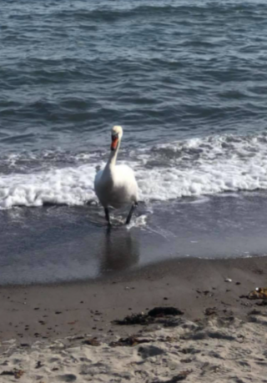

Figure 1: Mute swan - photographed 20/04/21 at Borre beach

**Scientific name:** *Cygnus olor*

**Appearance:** The mute swan weighs between 10-12 kg. It’s height is about 1,4m-1,6m and has a wingspan of 2,4m. The swan’s feathers are white and it has an orange beak.

**Nutrition:** The diet of the mute swan consists of mainly water plants.

**Habitat:** Aquatic areas being ponds, lakes, urban made water areas etc.

**Spread in Norway:** <https://bit.ly/3eIOZzD>

2) Herring gull

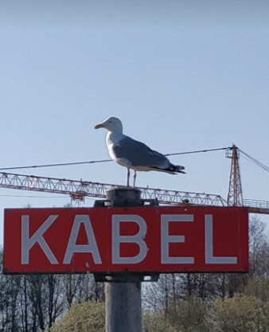

Figure 2: Herring gull - photograped on 19/04/21 at Rørestrand

**Scientific name:** *Larus argentatus*

**Appearance:** The herring gull has a weight of 1,3kg and it’s height is 65cm. The gull’s head, belly and tail have a white colour. The wings and back of the gull are grey. The bill is yellow and sharp at the end.

**Nutrition:** They eat almost everything. Mainly small water crustations like clams or crabs but they also scavenge leftovers thrown away by humans.

**Habitat:** Mostly coastal areas, doesn’t go far away from the sea.

**Spread in Norway:** <https://bit.ly/2S8aTV9>

**Sound:** <https://youtu.be/pTUicNPOKLU>

3) Black grouse

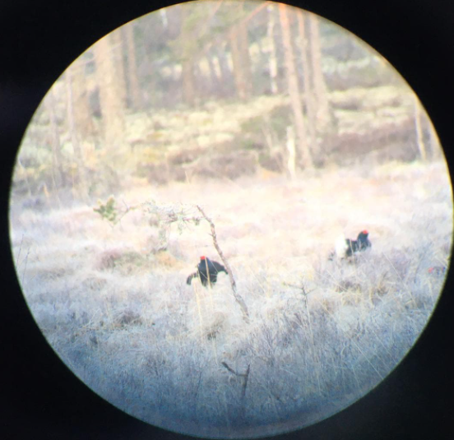

Figure 3: Black grouse - photograped on 27/04/21 at Halden

**Scientific name:** *Lyrurus tetrix*

**Appearance:** The male and female black grouse differ from each other. The male is black with some white feathers on the back and red spots on top of its head. The female black grouse is more a brown colour.

**Nutrition:** In the winter they feed themselves with needles and seeds from pinecones. In the summer they eat the berries that grow in the area.

**Habitat:** Forest areas with some open places like bogs.

**Spread in Norway:** <https://bit.ly/2PEZQlv>

**Sound:** <https://youtu.be/dziEmUjTcTM>

4) Western capercaillie

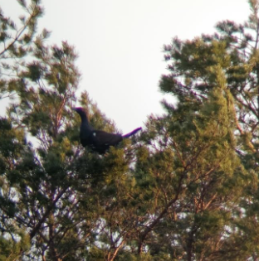

Figure 4: Western capercaillie - photographed on 26/04/21 at Halden

**Scientific name:** *Tetrao Urogallus*

**Appearance:** These birds also vary between male and female. The males are much bigger than the females. The male is dark grey to a black colour meanwhile the female is more a brown colour. It is a very heavy bird with a weight of 3kg.

**Nutrition:** Depending on the season the food changes but mostly pines and when berries are available they eat these.

**Habitat:** Forest areas with some open places like bogs.

**Spread in Norway:** <https://bit.ly/3nBv1Lf>

5) Rock dove

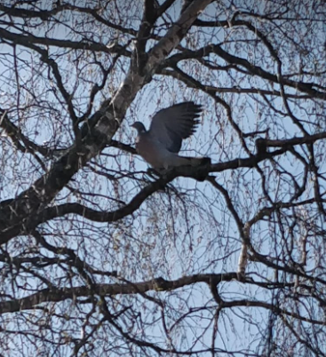

Figure 5: Rock dove - photographed on 19/04/21 at Borre

**Scientific name:** *Columba livia*

**Appearance:** Rock dove’s weigh between 250g and 550g. They can reach up to 40cm in height. They have grey feathers and around the head you can find blueish shiny feathers and on the neck it transfers to a green/red glossy colour.

**Nutrition:** Seeds, berries, scraps from human food.

**Habitat:** Cities, villages, semi-open areas.

**Spread in Norway:** <https://bit.ly/3xEqyfi>

6) Sparrow

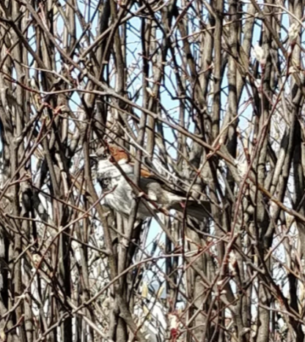

Figure 6: Sparrow - photographed on 19/04/21 at Borre

**Scientific name:** *Passer montanus*

**Appearance:** On the head it has some brown/dark patches. Both the male and female are the same size and coloration. It is a small bird with a height of about 15cm.

**Nutrition:** Seeds, insects and fruits.

**Habitat:** On the edge of villages, near places with trees and bird feeders.

**Spread in Norway:** <https://bit.ly/2S8eJxx>

**Sound:** <https://youtu.be/Nzx2pzGrVzo>

7) Crane *sound only

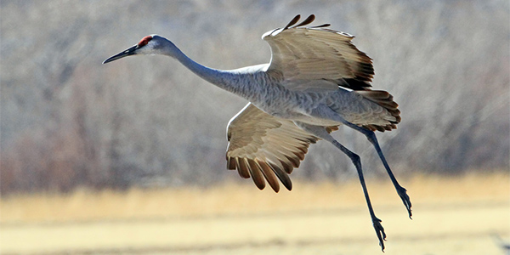

Figure 7: Crane bird - photo for example

**Scientific name:** *Gruidae*

**Appearance:** Crane birds are big birds with long legs. They also have a long beak and neck. Most crane birds are migratory except if they live in warm areas. The crane birds in this video are more than likely migratory crane birds.

**Nutrition:** Small animals, fish, seeds, berries.

**Habitat:** Forest areas, bogs, swampy area.

**Spread in Norway:** <https://bit.ly/3t8iPmh>

**Sound:** <https://youtu.be/P8rsdPgVZYI>

8) European robin

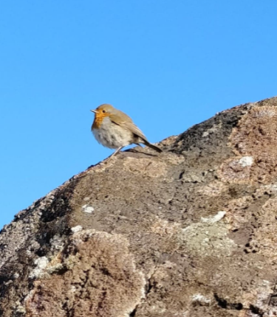

Figure 8: European robin - photographed on 22/04/21 at Borre

**Scientific name:** *Erithacus rubecula*

**Appearance:** Orange breast with light grey feathers on the lower body. On the upper side of the bird there are dark grey feathers.

**Nutrition:** Insects, worms, berries and fruits

**Habitat:** Spruce woods, parks, garden area

**Spread in Norway:** <https://bit.ly/3u9ZrGX>

9) Great tit

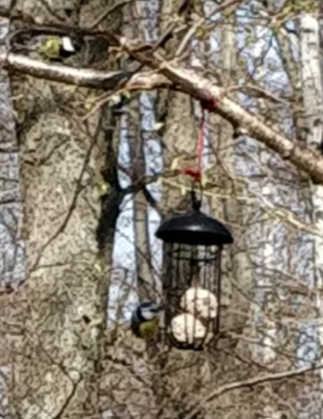

Figure 9: Great tit - photographed on 19/04/21 at a bird feeder near Borre

**Scientific name:** *Parus major*

**Appearance:** Black head and neck, prominent white cheeks, olive upperparts and yellow underparts, with some variation amongst the numerous subspecies

**Nutrition:** Insects, seeds, berries.

**Habitat:** Open woodland, mixed forests

**Spread in Norway:** <https://bit.ly/3nAOzPQ>

**Sound:** <https://youtu.be/gNURHSMRbjU>

10) Crow

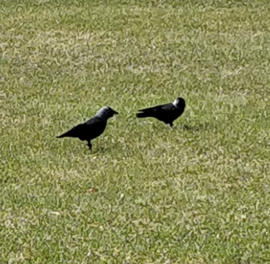

Figure 10: Crow - photographed on 19/04/21 at Borre

**Scientific name:** *Corvus*

**Appearance:** Black – robust and slender appearance, equipped with a small rounded head with a strong conical beak, elongated and pointed, with a slightly curved end towards the bottom

**Nutrition:** Almost everything – seeds, fruits, nuts, insects, other birds,…

**Habitat:** Open areas with nearby trees, agricultural areas.

**Spread in Norway:** <https://bit.ly/3gT8Mih>

11) Mallard

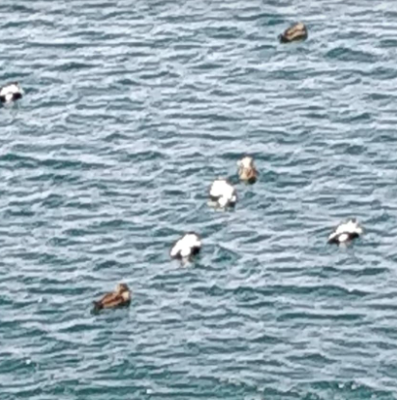

**Scientific name:** *Anas platyrhynchos*

**Appearance:** There is a difference between the male and female mallard. The male has a green glossy head and has a grey/brown body. The female is completely brown with some spots.

**Nutrition:** seeds, fruits, nuts, insects, bread.

**Habitat:** Aquatic areas

**Spread in Norway:** <https://bit.ly/3aT0H9N>