Bird ringing:

**1. How are birds caught for ringing? Explain catching method(s), equipment etc, preferably with drawings. Specify which rings they use (sizes, metal etc.)**

In Austria we are using rings from the Swedish brand “Mekaniska”.

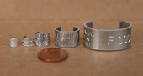[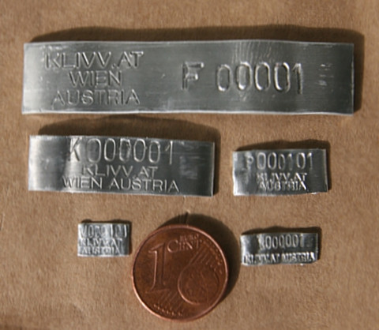](https://www.vetmeduni.ac.at/fileadmin/_processed_/b/8/csm_Ringe_IMG_8897_%C3%BCberarbeitet_AH2_1b2b53ea11.jpg)

Österreichische Ringe mit Aufschrift (Foto: W. Vogl)

On this link you find the exact information about the rings which we are using.

 <https://www.vetmeduni.ac.at/fileadmin/v/klivv/AOC/AOC_Oesterr_Ringschema.pdf>

At the same time and same place every year the birds get caught with the net. Form the beginning of May till the end of August. They start in the dawn for six hours. All in total 12 days. At the beginning of the year some of the places are still full of snow. If this is the case, they should try to catch the birds the last eight days.

Ein Bild, das Text, Screenshot, Stadt, schließen enthält.

It is not allowed to catch birds on other days. There have to be a gap of 5 days in between. The nets have to be set up the day before. They are closed during the night and will get open before the sunrise. It is forbitten to use food, sounds or other birds to decoy. Unfortunately we can’t find more information about the nets they are using.

**2. For how long time have birds been ringed (in the world and in your country)?**

In the year 1899 Hans Christian Cornelius Mortensen started the first bird ringing in Denmark.

**3. What can we find out by ringing birds?**

If we catch the birds, we can measure lots of information’s about them. Following characteristics get observed as species, gender, age, weight, wingspan and condition of the bird. If we ring birds over a long time, we can find out the differences in the population. Over this we can look at the reasons why the population is bigger/smaller for example the climate change. Due to the rings we can also see the movements of the birds.

**4. What to do if you find a ringed bird?**

If you find a ringed bird in Austria, you have to download a paper and fill out some different things:

- information on the ring like ringing center, ring number, date

- exactly finding place with coordination data

- How could you read the information from the ring?

- Do you know the species of the bird?

- How is the condition of the bird?

- Is the bird dead/ injured?

- If the bird is dead, for how long?

- If you cached the bird, did you let it free again, where and when?

- Do you know the gender, the age or more about the bird?

- Personal address of the person who found the bird.

<https://www.vetmeduni.ac.at/de/klivv/oesterreichische-vogelwarte/beringungszentrale/vogelberingung/> 28.04.21