BEACH TASK ANIMALS

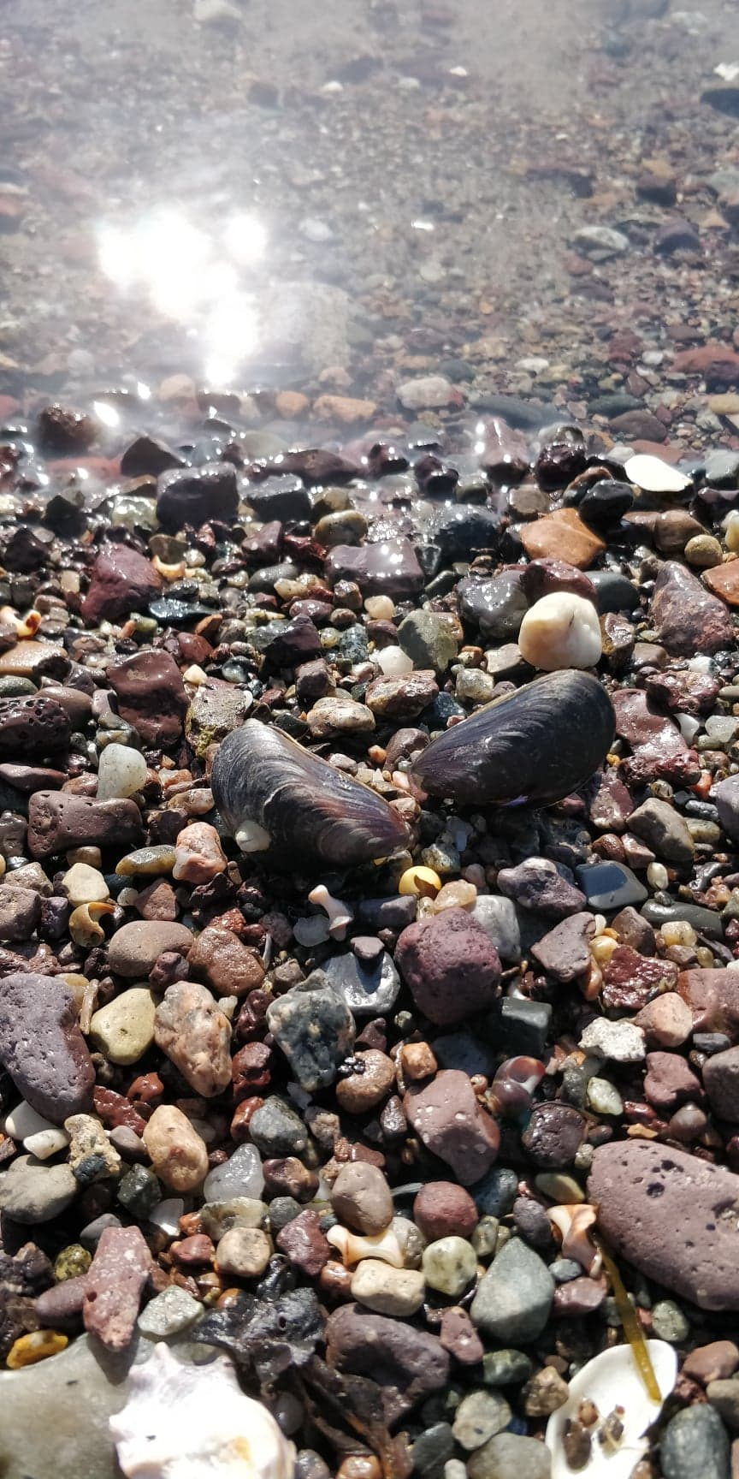Blue mussel - *Mytilus edulis*

Oysters – *Ostrea Edulis*

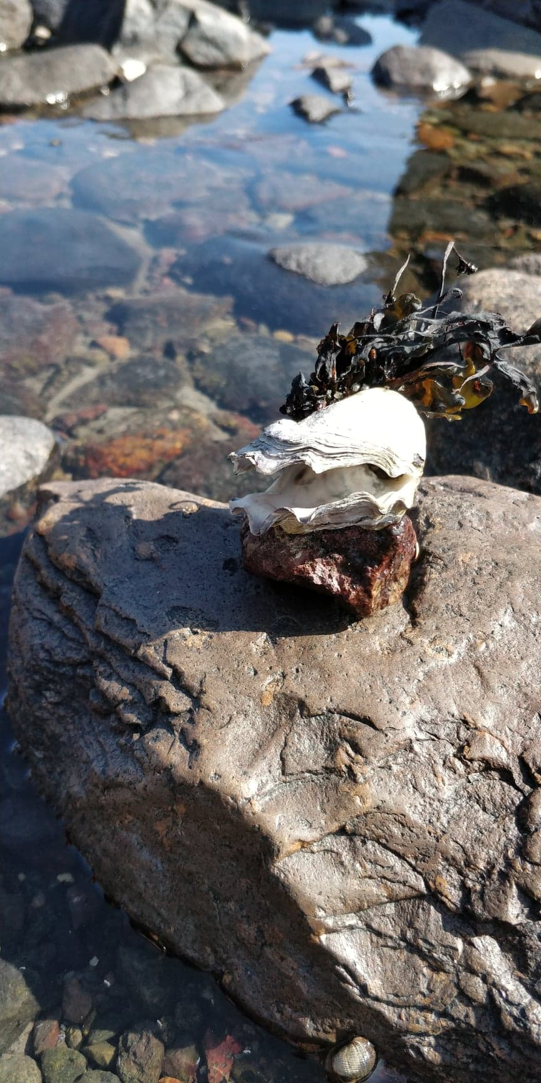

Pacific oysters - *Crassostrea gigas*

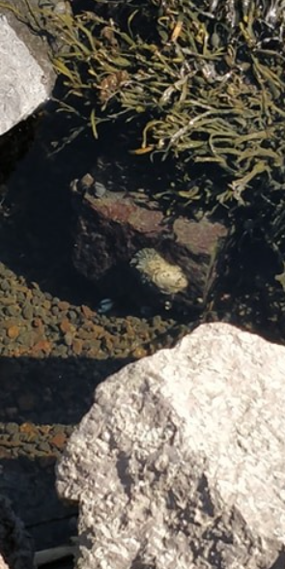

Soft shell clam - *Mya arenaria*

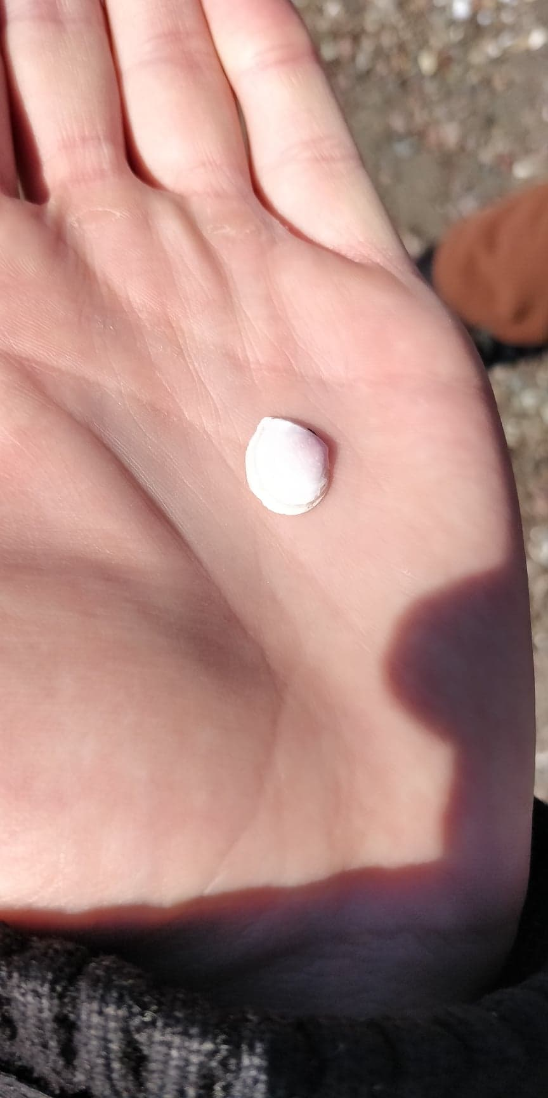

Common periwinkle - *Littorina littorea*

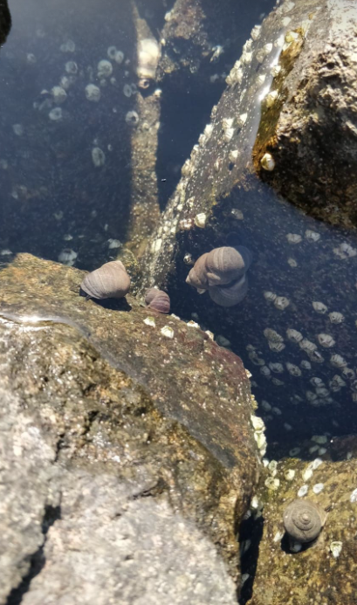

Flat periwinkle - *Littorina obtusata*

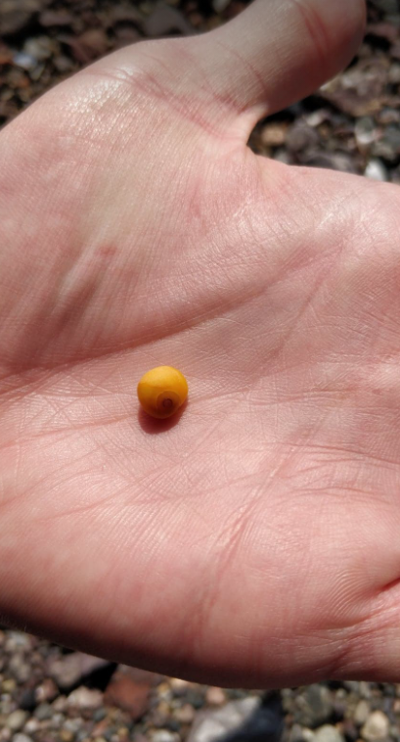

Sjøstjerne (korstroll) (Asterias rubens)

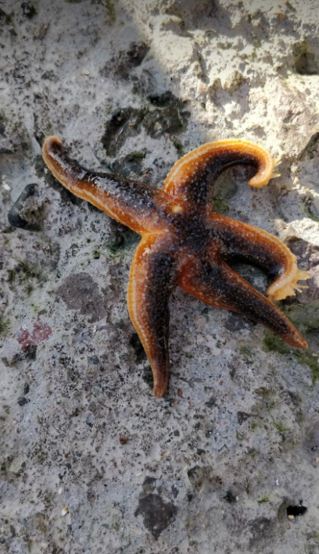

Barnicle (Balanus sp.)

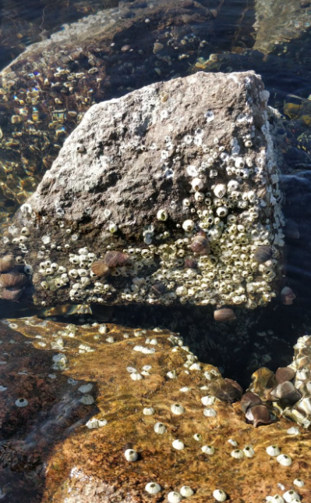

Strandkrabbe (Carcinus maenas)

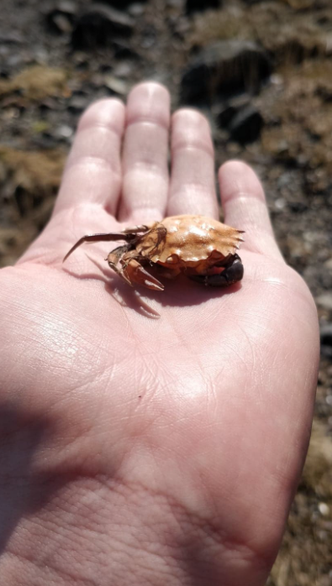

Sea centipede – *Batedotea elongata*

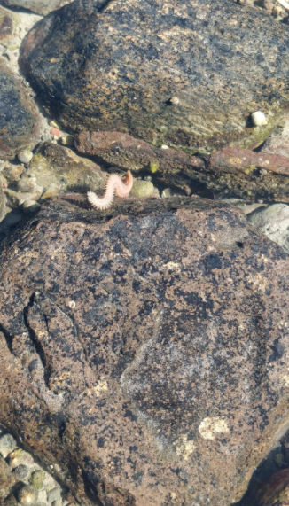

Beach tasks algae

Blæretang (Fucus vesiculosus)

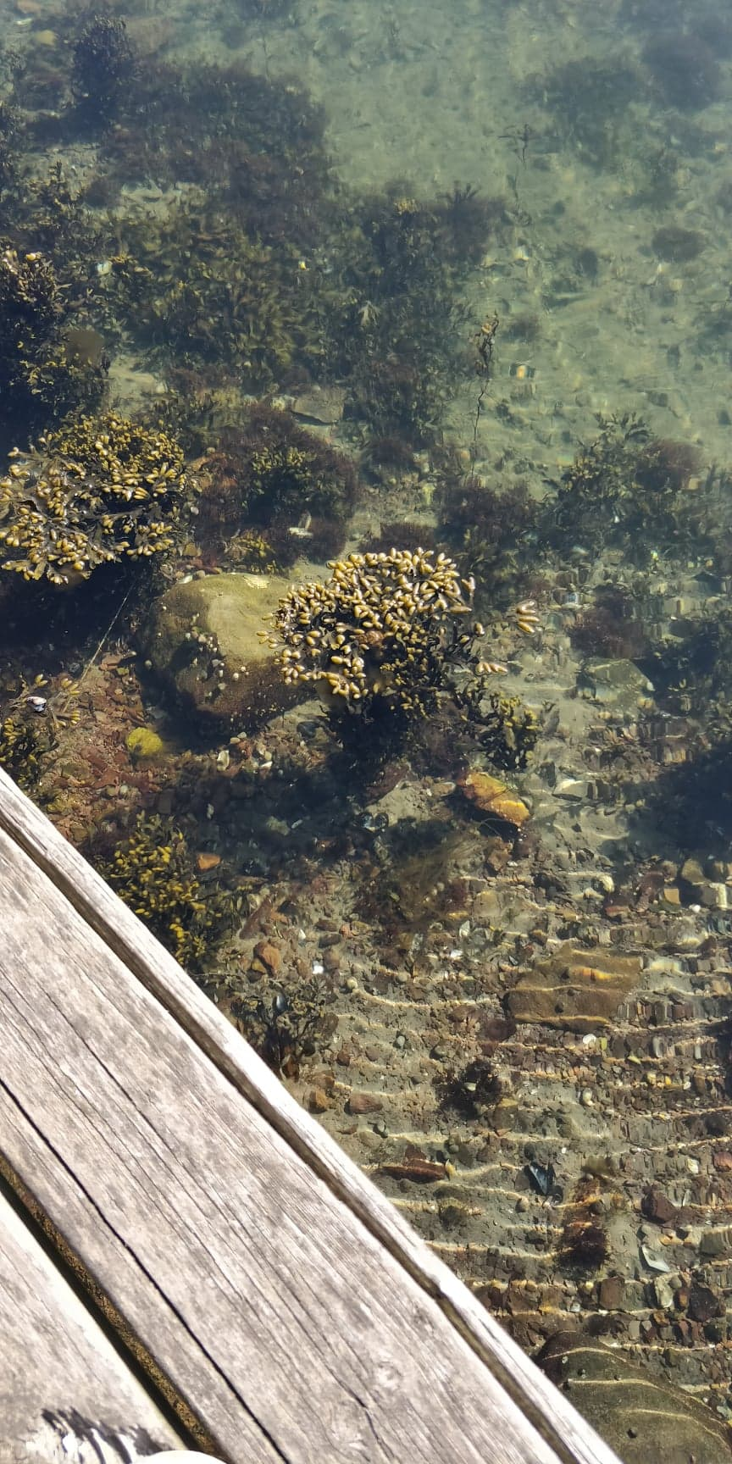

Tarmgrønske (Ulva intestinalis)

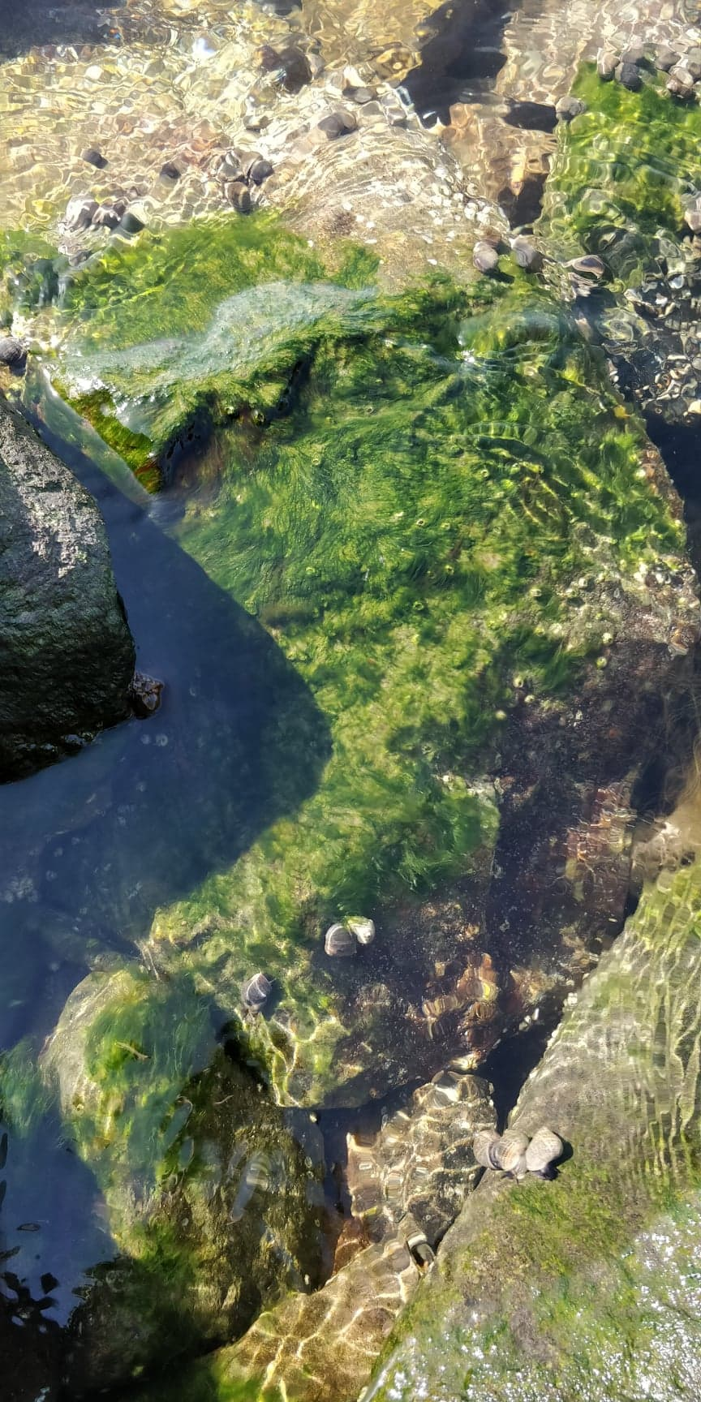

Krusflik (Chondrus crispus)

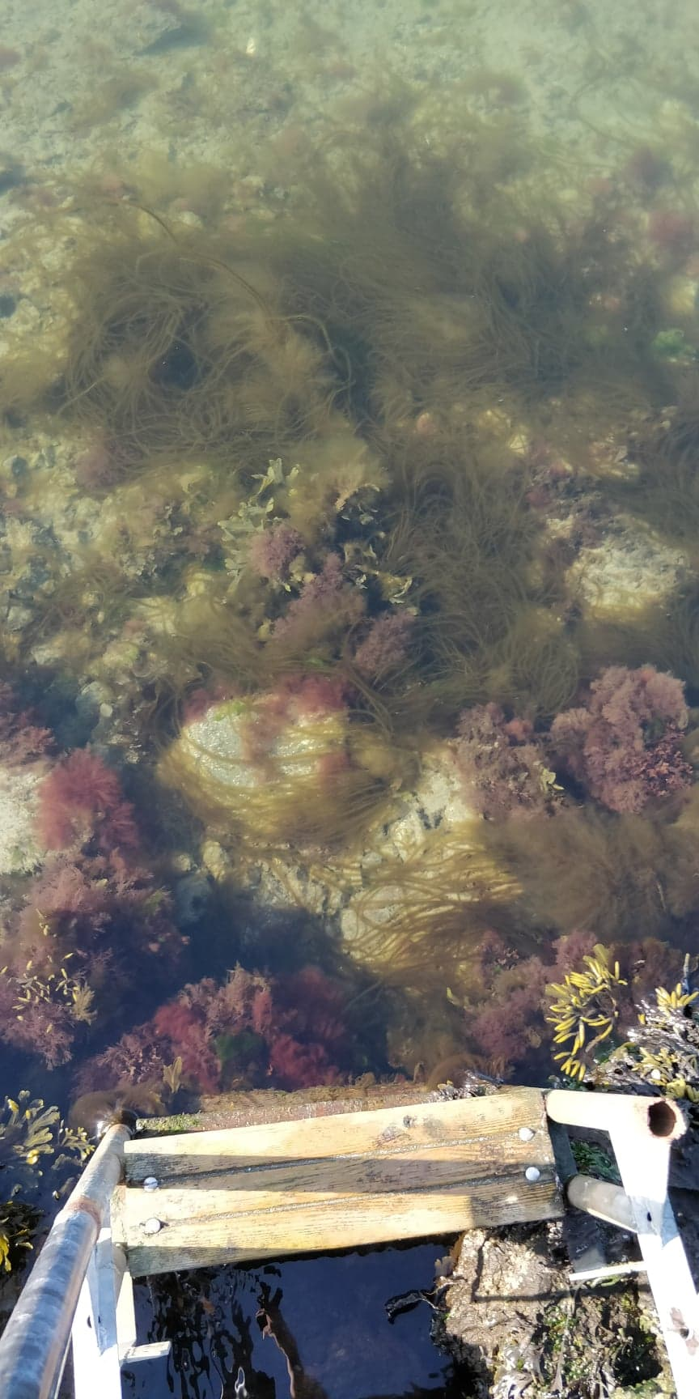

Svartkluft (Furcellaria lumbricalis)

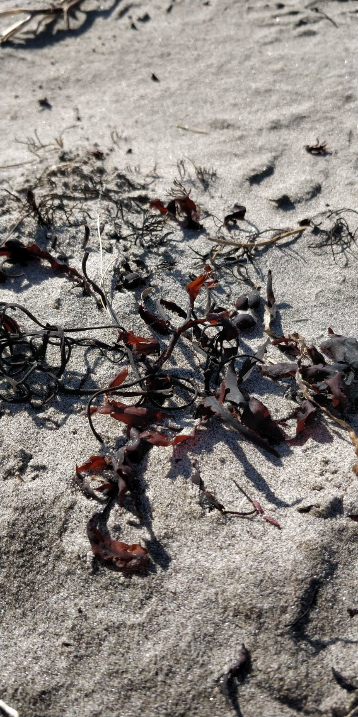

Sagtang (Fucus serratus)

