***Name:*** Megan Hogan

***Student Number:*** 228235

***Lecturer:*** Kari-Anne J

***Word Count:*** 1808

***Title:* Place based – learning and affordance of a landscape**

***Submission Date:*** 22nd of February 2019

Throughout this assignment learning and affordance of a landscape will be discussed and how thy influence a child’s play. I will give definitions of place based learning, risky play and affordance. The affordances that are offered to an individual in an area we visited and I will describe my home-place and what nature means to me.

**Place based Learning:** Emphasizes learning through participation in the outdoors. Pedagogy of place provides the opportunity for students to immerse themselves in local heritage, landscapes, cultures and environmental education. This way students can learn from their experiences rather than being stuck inside four walls learning from a book each day. Learning through pedagogy of place or place based leaning allows students to experience the certain moments on their learning and these moments are real and meaningful to them. ‘Place has to do with the relationship between people and their local setting for their experience and activity’. (Wattchow & Brown, 2011).

**Risky Play:** Is an activity that is both exciting and thrilling with the risk of physical injury or harm. Risky play is divided into six categories and these consist of play with heights, speed, dangerous tool, play near dangerous elements, rough and tumble play and play where the children face the possibility of getting lost or disappearing. Risky play tests children’s limits and provides them with challenges they can overcome through taking risks. It gives them the opportunity to step out of their comfort zones and experience thrills within their free play. There is a big debate on how much interference from adults there should be within the aspect of risk play. (Sanseter, 2009).

**Affordance:** Is what the environment has to offer to an individual. ‘The affordance of the environment is what it “invites” us to do’ (Sanseter, 2009). The term affordance considers the wide range of possibilities and the use of space within an environment to enhance children’s play and learning experiences, especially in the early years. The term of affordance can also be considered for children who experience outdoor learning (Waller, 2017). Examples of affordances in a preschool setting- Climbable feature afford climbing, flat or smooth surfaces afford the opportunity to run, cycle, skate or ski and slopes and slides afford sledging, sliding or cycling (Sanseter, 2009).

During week seven we visited a number of different places over two days. For the purpose of explaining affordances and learning I will describe the affordances that stood out to me on out outing in Horten. The first place we visited was the square in Horten. From observing these areas I noticed that there were many opportunity for children to play, and many affordances.

There were many piles of snow in all areas of the square and this would account as a climbable feature or a slope/slide. Here the children can climb up the pile of snow and then slide or sledge down the small hill. Other climbable features that were in the park include the steps and the cannon structure. There was also a fire pit down in the square. This can give the adult the opportunity to teach the children about the safety of fire and how to take care when in the presence of a fire. It can also allow the children to play with dangerous tools as they could use a saw, axe or knife to cut up the fire wood to use on the burning fire if they intend on lighting it (Sanseter, 2009). There were some drums and a xylophone which can give the children the opportunity to make music and explore the different sounds and echoes the instrument make. There was also a tight-rope which is a balance-on able feature in the park. 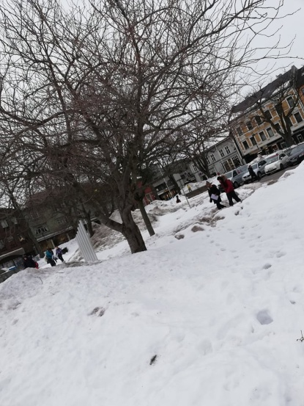 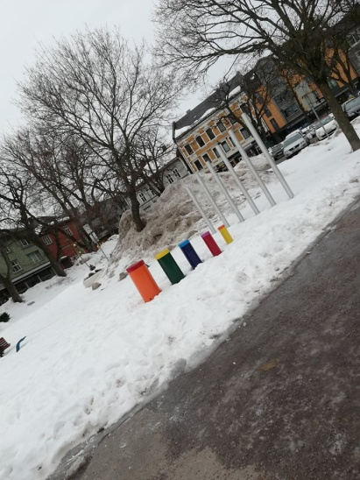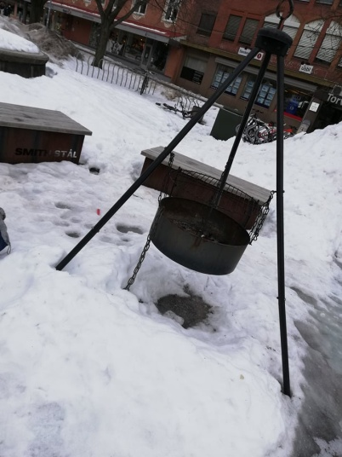

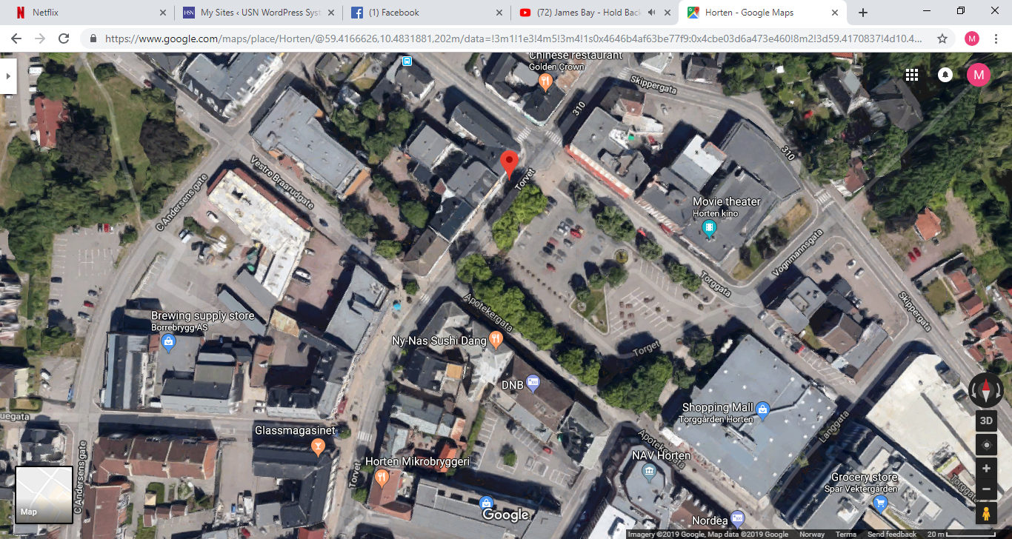

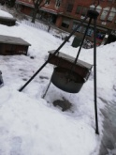

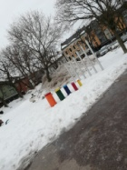

Next we went on to a park where there was a traditional playground with two different swing sets, two climbing frames and a hammock. Around the park hidden in the trees were also little fairy doors which give the opportunity for children to use their creativity and imagination. This could then be led onto a story telling activity. All of these elements in the park offer affordances to the children. The climbing frames give children the opportunity to climb, balance and jumping. There was also a horse sculpture that children could also use as a climbable feature. The swing able features include three different swings sets. One for little children, another for bigger children, a basket swing for anyone and also a hammock quiet close to the ground. These swing features give the children the opportunity of swinging at great heights and at a great speed which is an element of risky play.

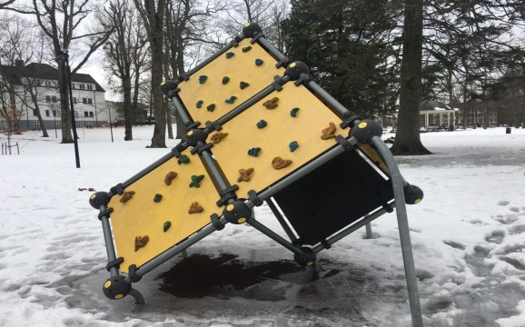 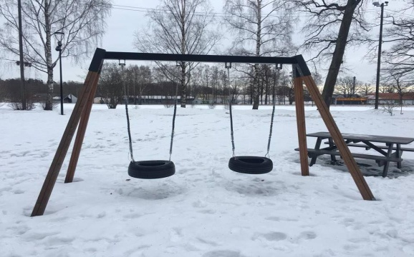

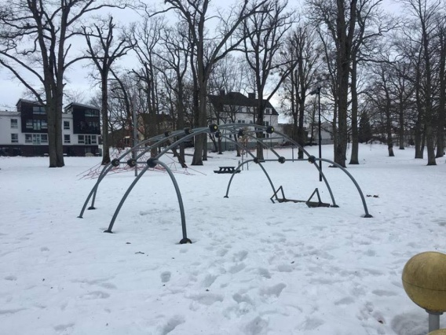 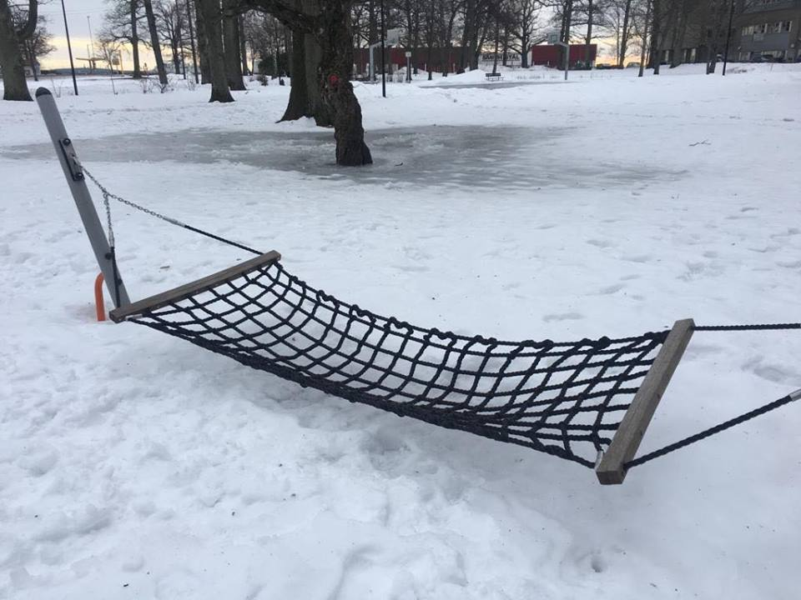

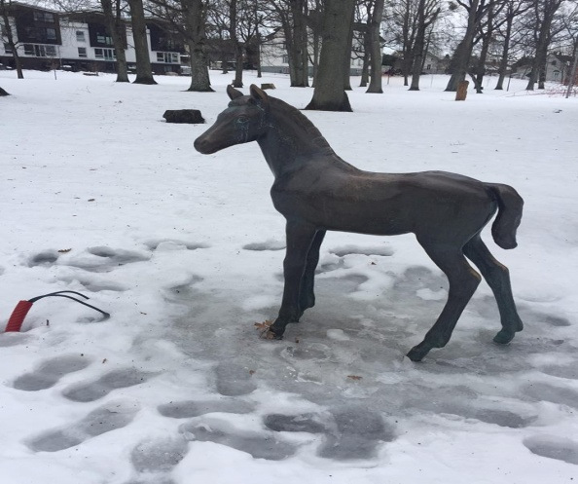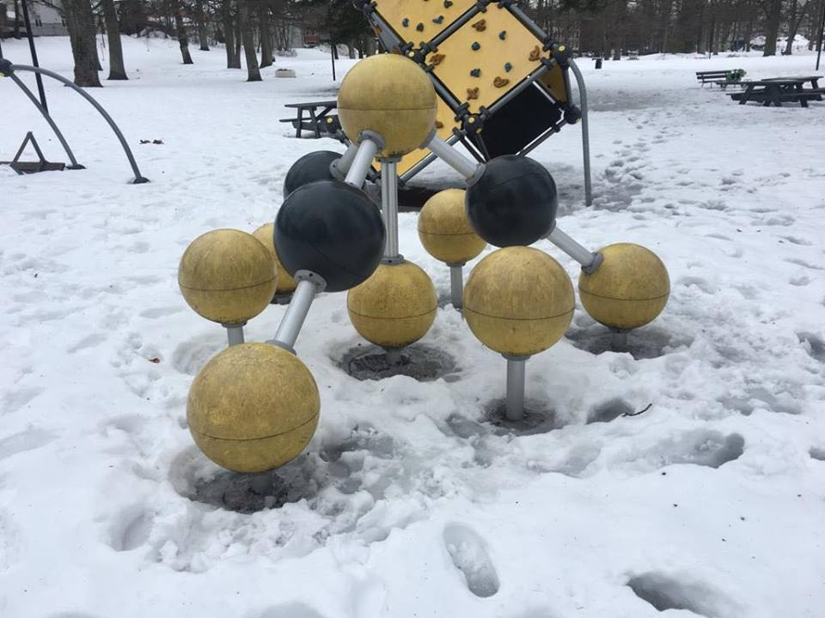 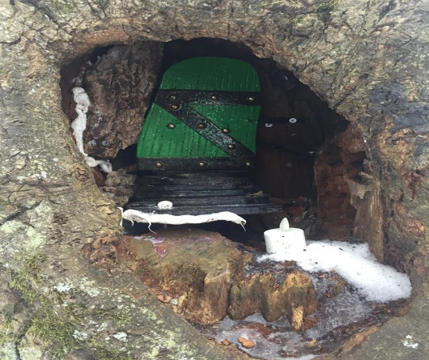 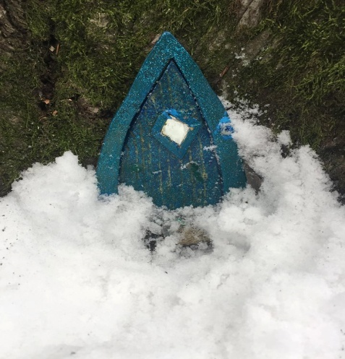

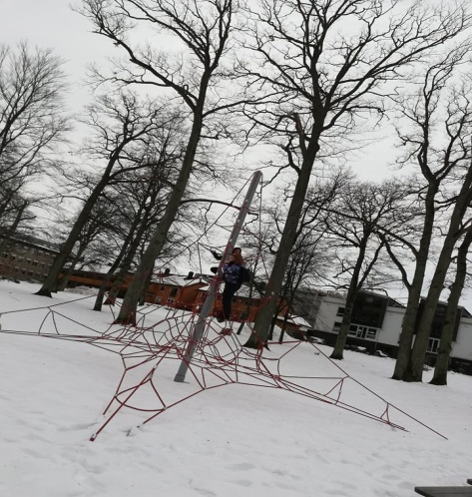

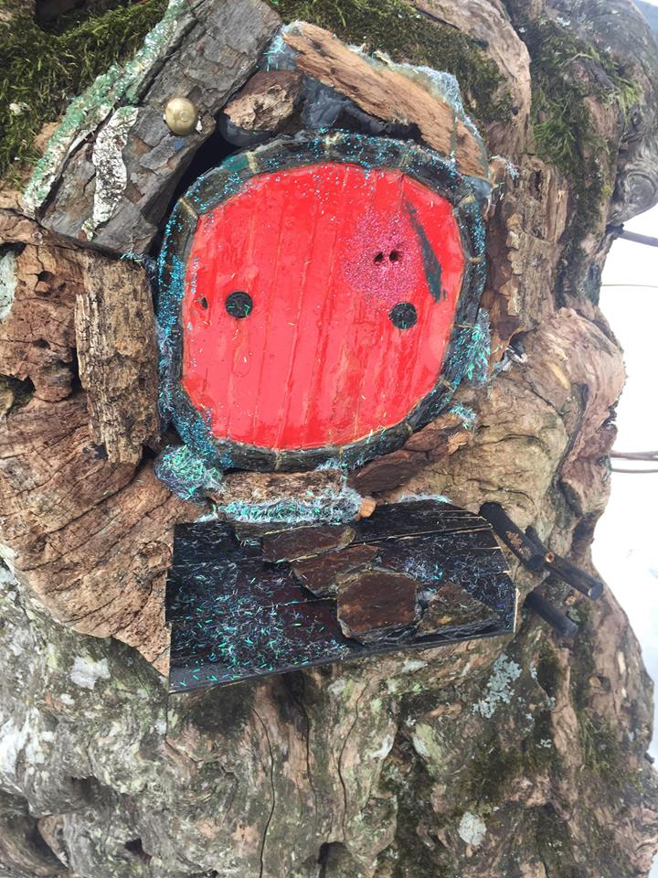

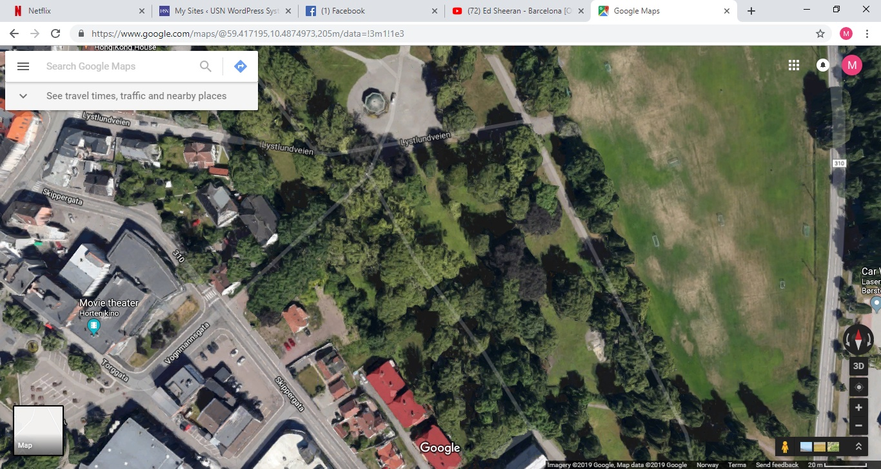

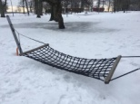

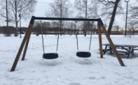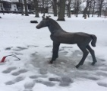

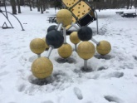

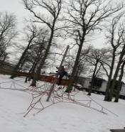

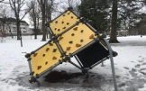

Next we went along the coast line to play some games and explore the area. When we followed the walk way into the forest it was flat and smooth surfaces. This area affords cycling, running, skating and or rough and tumbles play. There were also some fallen sticks and branches that they children could use during creative and imaginative play. They could play fight with the sticks and pretend they are swords. They could make a hut with the fallen branches and sticks. I think any of these activities can be encouraged all year round despite weather conditions. We were surrounded by trees give the opportunity for children to climb. The sea also gives a lot of opportunities for children to play and learn. They can do many water sports, learn how to fish, we were taught what mussels looked like when we visited the coast. We could pass this onto the children and ensuring we pick and take the right mussels we could then take them and cook them. There were many stones on the coastline; these would be considered as graspable objects. The stones can be thrown into the sea or along the sea shore. Along the walk there were many features that caught my eye that act as balanceable features or children. These features include, large rocks down by the sea front, a numerous amount of fallen branches on the walk way and small edges (Sanseter, 2009).

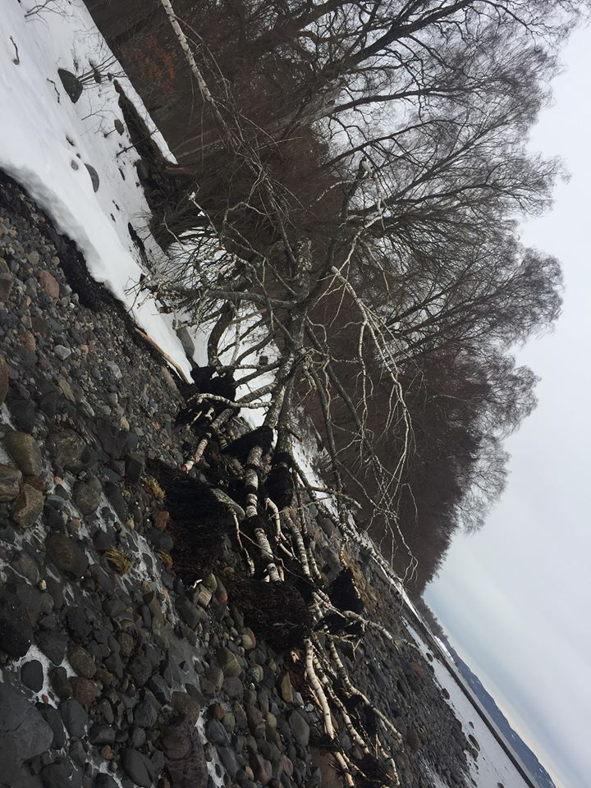 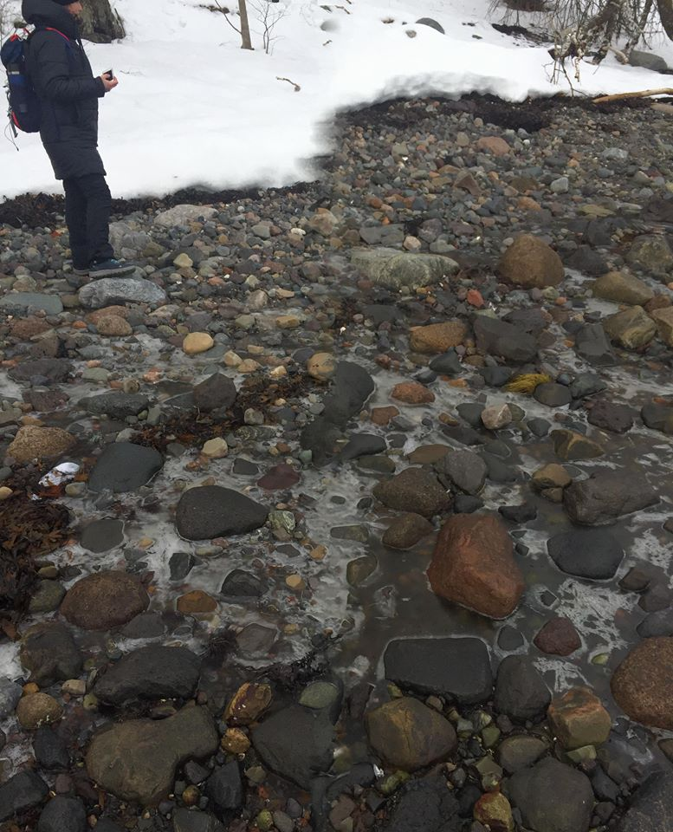

Although all of these affordances are great for children to grow and learn and make the most of their surroundings, we should take certain factors into consideration. When taking the children out we should definitely allow them to take chances and explore risky play. We just need to ensure that we are aware of the dangerous areas in our surroundings. On this trip the biggest dangerous area for me would be the sea. When children are near or in the water they should be supervised but also allowing them to explore the environment. The fire pit is also another dangerous element that should be taken into consideration only when it is burning though. It wouldn’t be a bad idea for the teacher to check if it was hot before the children started to play near it in case someone had been their previous to the arrival. On our excursion there were many affordances and aspects that can enhance children’s play and learning experiences in the outdoors.

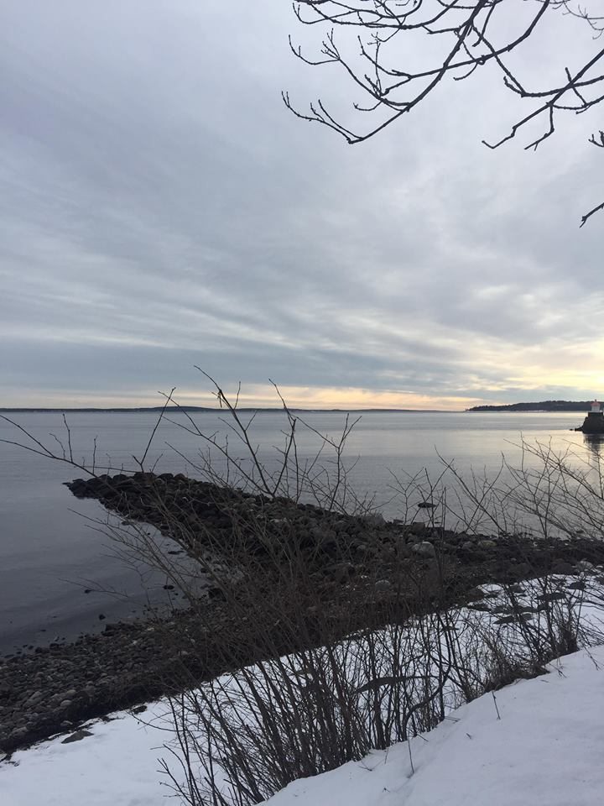 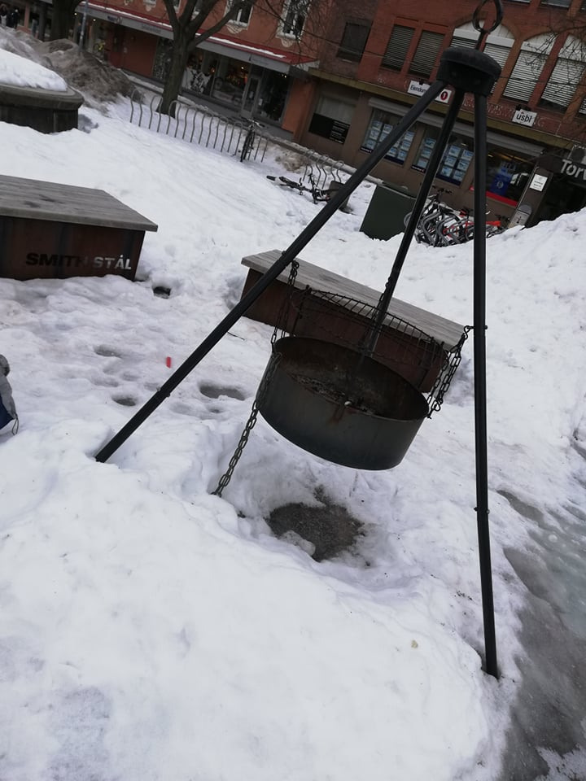

**‘Me as an Outdoor Teacher’**

I live between two places Dublin and Westmeath. My home town is Mullingar in county Westmeath. Westmeath is situated in the mid-lands which is right in the centre of Ireland. Mullingar is the third most popular town in the midlands. It has a number of lakes and Westmeath is also known as the lake county. These lakes are one of the town’s main tourist’s attractions. Lough Owel, which allows for people to go fishing or rowing. Belvedere House and Gardens is a gorgeous woodland and nature area that has a lot to offer all year round. The lake of Lough Ennel also meets the nature area of these gardens. Lough Derraveragh offers camping facilities and it is also permitted to boat and fish in this area. Lough Derrvagh is known for its connection to the Irish ledged the Children of Lir. Mullingar’s most notable building is the cathedral which is located in the town centre. The town has many sports and recreational services available. These include cycling, equestrian centres, swimming, running, football rugby and much more. Mullingar is a town full of great and upcoming musicians some of who are known across the country and further afield. The town has several primary schools and four second level schools and a wide range of preschool services. There is also a park located in the town which offers a variety of playgrounds, a swimming pool, and a large pond in the centre. This is a very beautiful place to spend summer days.

Nature is something I have always appreciated but never really had much respect for as a child. Although I was always encouraged to go outdoors and experience nature and my surroundings in my area, now that I am older I have more knowledge about how the world works and the importance of keeping a clean environment in order to have a healthy world. For me nature was always something that was just ‘there’. I never thoroughly experienced its true beauty and affordances until I started college. When I am having a bad day, feeling down, stressed or worried I always find myself turning to nature. The majority of the time it will be a walk on the pier or a trip to the lake, depending on where I am. This could be Westmeath or Dublin. Embracing these surroundings distresses me and helps me to gain a peace of mind. I now know how to respect and appreciate the world we live in and I want to encourage children to do the same. My local area has a lot to offer this ranges from taking a walk in the park or woodland area, camping or exploring land marks the possibilities are endless. I chose this course as it would be a totally new experience for me to attend college in a different country. I am a person who is willing to try everything at least once and I always jump at opportunities that come my way. I am not afraid to take chance and I think this was the way for me to experience a college course in a new country. I have heard so much about the Norwegian style of teaching children in the early years, and how outdoor learning is such a positive factor for children in the early year’s sector. So what better way to experience the Norwegian culture and teaching styles than coming here to experience it firsthand? I am excited to see what I learn and take away from the course of outdoor and experiential learning so I can bring it home and put it into practice and share my experience with other like-minded people. I am open to all new learning opportunities and am ready for whatever it is the semester has in store.

# Bibliography

Sanseter, E. B. (2009). Affordances of Risky Play in Preschools: The Importance of Features in the Play Enviroment. *Early Childhood Education Journal* , 439-446.

Waller, T. (2017). *The SAGE Handbook of Outdoor Play and Learning.* London: SAGE.

Wattchow, B., & Brown, M. (2011). *A Pedagogy og Place- Outdoor Education for a Changing World.* Victoria: Monsash.

All maps taken from Google maps