My practice at Kruge Leirskole

Week 16 and 17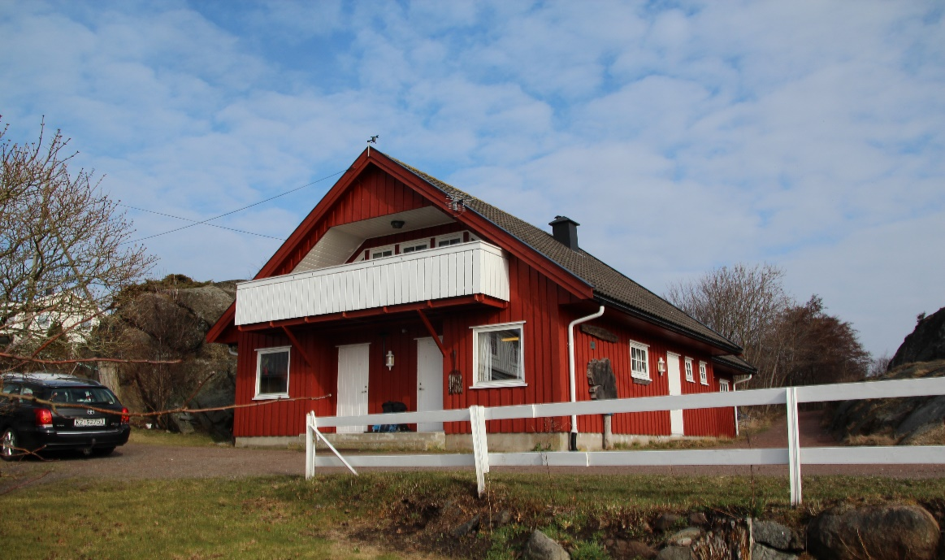

Index

1. Basic Information about Kruge Leirskole
2. Activity and Personal Reflection
3. Basic Information about Kruge Leirskole

Kruge Lierskole is located at the south of Vestfold, Hvassa in Tjome community. It takes one hour and half from Borre. Hvassa is popular for Norwegian summer vacation. This nature school, Kruge Leirskole is run by three main organizers, Eric, Paal and Mona. Eric and Paal are nature guides there, and Mona works as “Mat Mom” in the main building. We Anne, Clemens, Sarah and Hikaru spent two weeks as practice students there and met the kids (11-13 years old) in two weeks.

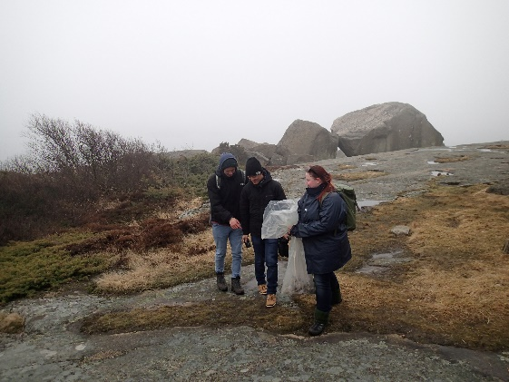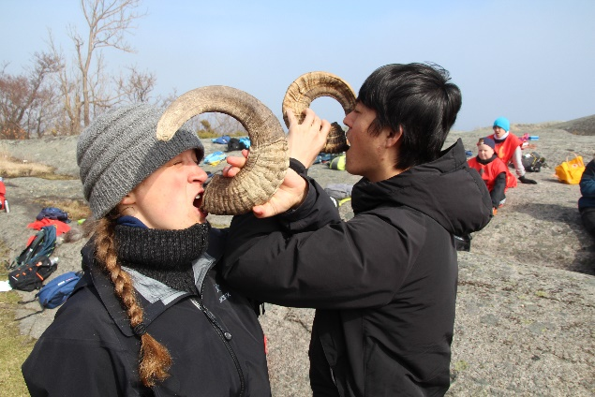

1. Activity and Personal Reflection

Monday: 16.04.2018 and 23.04.2018

We arrived at the school at 10:30 am. We met nature guides Eric and Paal and started preparing for the kids coming that week. First, we went to the beach down from main building to drag down some sea kayaks and canoes to the harbor.

Second, after the kids arrived at the school. We all were together on the lawn and Eric and Paal talked about us and made sure how and where the kids drove through and arrived at the school finally. Third, Eric and Paal let the kids go to their own cabin, and those nature guide wrote kids name down on the table of daily tasks for individual. For example, cleaning their own room and common space each day. It was specific way to make sure their responsibility. Finally, they ate lunch and take their own life jacket to rolling sea kayak and sea canoe. We practice students went to the bay together to make sure that kids go farther away. But the kids coming in the week 17 faced difficulties because of the strong wind in the bay entire the week 17. It was too difficult for kids to manage rowing in windy condition.

I had three interesting experiences there on Mondays. First, I didn’t expect to ask them for the route from where they are to the school. I realized Eric and Paal not only made the kids understand where we are and also those nature guide provided the opportunity learning geographical knowledge and sense to the kids. Second, I found interesting differences from Japanese sense of moral education when those two nature guides talked about the routine work at the school, because Japanese teachers generally have the kids and students recognize roles and responsibility before going to trips. Finally, I was interested in the way to have kids be aware of wearing life jackets because if the kid wearing the jacket go shopping for free time, they can get some discount there. It is a effective way to keep them wearing the life jackets. And I felt that the school have built good partnership with the local people and community.

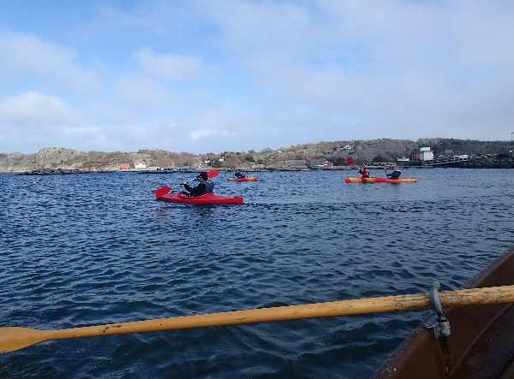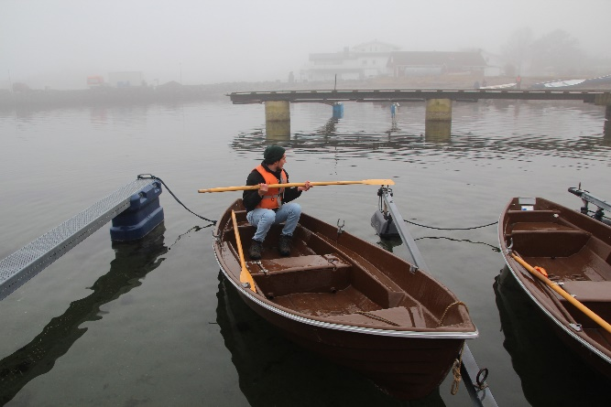

Tuesday: 17.04.2018 and 24.04.2018

Before I and Clemens arrived at the school, Anne, Sarah and the kids took the morning bath which they went to a beach at 8 am and went through the beach. Firstly, they had breakfast and we started working around the coastline. We picked up cells to figure out what kind of cell live in the beach in the island. At the same time, we also collected some plastic garbage during the walking tour. Eric and Paal talked about the history, geology, geography and the myth related to the island and Norway. The kids coming in week 17 were from an inland city, so they looked excited to find marine creatures along the beach. Eric asked me to carry out the special indoor lecture, because it was not good weather in 17 unfortunately. We prepared for an origami lecture in one hour. We found four diagrams to hold a crab, a jumping frog, a paper airplane and a crane on the Internet. There were fifty kids approximately at the school then, it was difficult for us to teach all of them how to hold origami, but the kids taught and help each other. When we finished holding those origamis, the weather got better, and they went out and flew paper airplanes outside. I felt that I can contribute toward corroborating Japanese culture and outdoor education.

I mention that what I learned on Tuesdays activities. I noticed three differences between Japan and Norway, the behavior of teacher, manual dexterity and the habit of collecting garbage. First, I felt the teachers from local schools should be involved in the activities with their own students. When we made origami, they just seat on the couch even though some students straggled to hold it and to understand the diagrams. In addition, I was only man how to know how to do that. I would like them to take part in and to be involved not only origami but also in the walking tour with kids on the day. Second, I was surprised at the difference of the manual dexterity. In Japan, we start learning origami from three years old at kindergarten. Some parents who interested in education let the kids do origami before entering kindergarten. We already get used to handwork like origami and crafting around five years old. I was interested in how schools make kids acquire hand work skill in the lecture through my origami experience at the Kruge nature center. Finally, there is different habit about garbage. In Japan, teachers have students take their own trash back to home after going on picnics. However, Norwegian teachers collect the trash from student’s lunch in the practice week. I think that it is a good opportunity to take responsibility of garbage and to think about the influence on the environment if they leave their own 　plastic wastes in the nature. 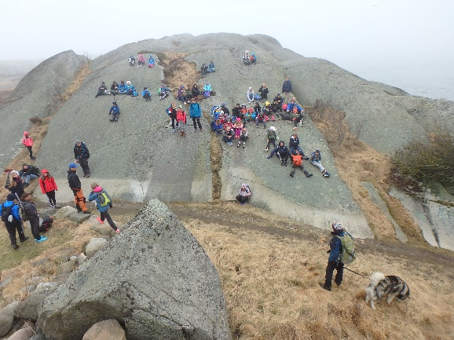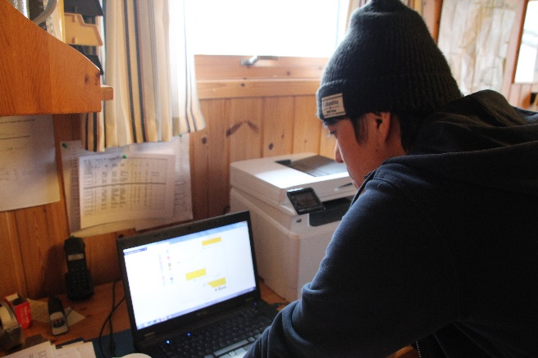

Wednesday: 25.04.2018 (absence:18.04.2018 because of contact to my Japanese Uni.)

Wednesday is the experimental day for kids. The activity in other weekdays except for Wednesday is to recognize their own ability for example how high and far they can jump over. But kids catch creatures around shore and forest and observe them following their curiousness every Wednesday. At the beginning of the day, the kids took the morning bath on the beach as their morning routine. After eating breakfast, the kids were divided into two groups. One group with Eric learned knotting and went to the other beach to make their aquariums. The other group with Paal went to offshore and fishing with fishing nets. The kids caught marine lives as much as they can and made their exhibitions with flounders, starfish, blue cell and seaweed. Each of group switched those two activities after taking lunch. First, Eric group went to beach and started making small aquariums and Sarah, Hikaru and local teachers marked the scores on each group. At the beginning of collecting marine creatures on the shallows, they cared about getting wet, but they didn’t worry about wetness suddenly as soon as they got wet. On the other hand, Paal group had a short lecture of equipment they use. Then Paal mentioned and esteem for the history of fisherman around Hvassa area. And also the group went to the pear after the lecture and took rowing bouts to pull up the fishing nets Paal left two days ago. They loaded two fishing nets and separated nets and fish carefully at the pear. Fish they caught were carried into a big green sink, the kids observed those fish.

Next, I want to refer to the two impressive moments on Wednesdays. One is the behavior when the kids seek for the place marine life lives. The other is kid’s curiousness to the nature area. I was surprised at the behavior to catch the marine life because they do not afraid of getting wet under the cold environment. The kids in Kruge nature school checked daily weather themselves. For example, temperature, humidity, water temperature and wind. When they measured those weather types, the temperature was under 10 degrees. If Japanese kids know the coldness and what they are going to do, they would hastate and be demotivated not only to take the morning baths in the beach but also to find lives around beach.

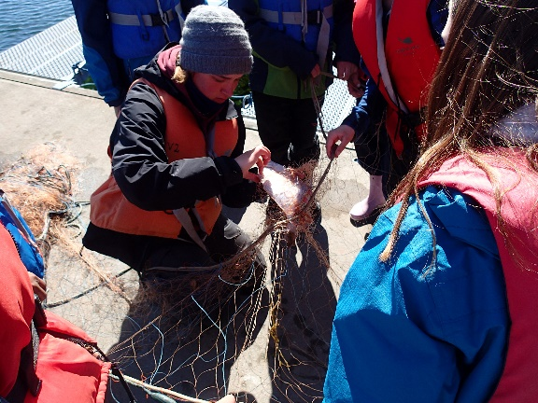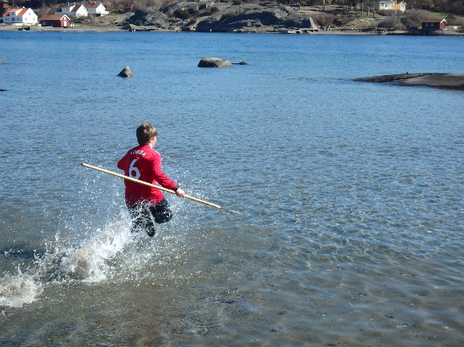

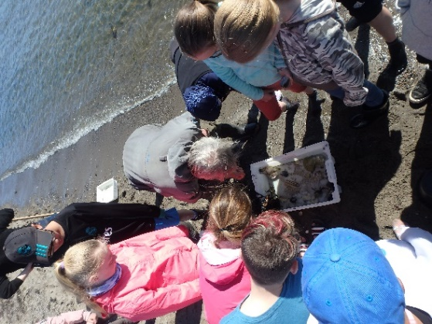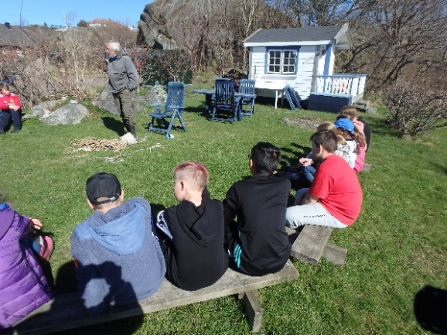

Thursday: 19.04.2018 and 26.04.2018

Thursday is Kruge Viking day. The kids learned the history and life of Vikings. On the day, kids were divided into two teams, the Viking King and the Viking Queen, and they competed in six athletic events. There were Tug-of-war, shouting, valance game, drink shot, rock tower, and beach sprint.

At the first of the day, Sarah, Anne and kids took the morning bath on the beach as usual. After the bath, they ate breakfast and chose the team leaders and special roles from each team. Eric and Paal asked volunteers to be candidates for the king and the queen. Then, the candidatures made speeches to be voted. The kids voted to leaders. The kings, queens and special roles wore their own costumes made of sheep skins Eric farmed. The other normal kids wore the team costumes which had black and gold crosses on the back. Each color of crosses is to distinguish team. Secondly, they departed from their main cabin, and Eric and Paal told them a lot of Viking stories, for instance, how to live and to compete with other Viking tribes. All of six activities I wrote above is related to Viking era and those lives. In addition, Eric and Paal combined Viking era culture with athletic competitions as pedagogical works. After kids experienced six athletic competitions, we went back from beaches, and kids acquired how to use bows and to shoot arrows like hunting Vikings. We, practice students, made sure that they could practice them in safe. Finally, they went back their own cabins to pack their luggage up for the departure on Friday.

For Thursday activities, I would like to write down three activities I was interested in next. They were shouting, rock tower and valance game. Firstly, Eric and Paal carried out the shouting competition as the opening match. The game is to compare the loudness of each team. I do not know both did it consciously first, but I felt that shouting made those kids much motivated and that the game provided eagerness and braveness to beat and overcome opponents for them. Eric and Paal made efficient atmosphere for kids involved in the games on the whole day. Secondly, I believe that the rock tower game was one of pedagogic works for kids, because they were given opportunity to find their own proper roles unconsciously. Each team leaders coordinated the strategy to build up the higher tower than the other team tower.

Some of kids brought rocks from somewhere. The others stack up the rocks to build the stable tower. They came up with various ideas to make the tower well-constructed and higher. Finally, the Viking valance game had an effective role to give girls chance to overcome boys. Two kids stand together on one timber and roll it until the opponent falls on the ground. Some girls often made boys down from the timber. I thought girls were better at valancing than boys then. When I coordinated PE class in my lecture as a trial class, I struggled to manage physical activities equally between boys and girls. In addition to my experience, Japanese teachers at elemental school sometimes face the problems of the ability gaps of gender.

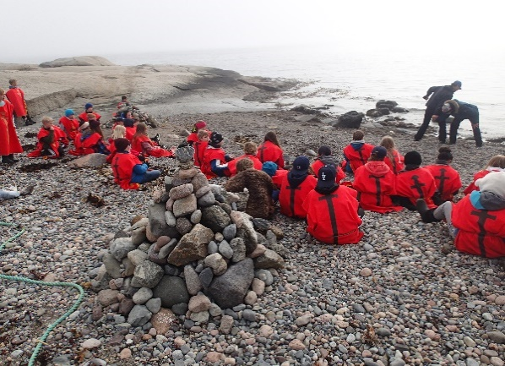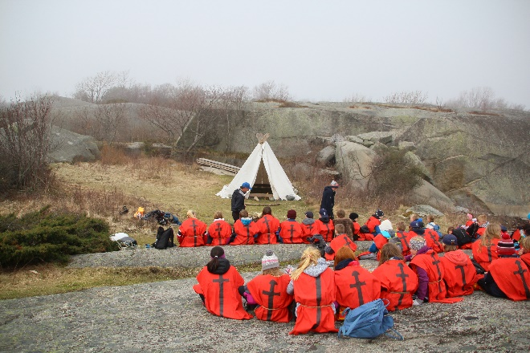

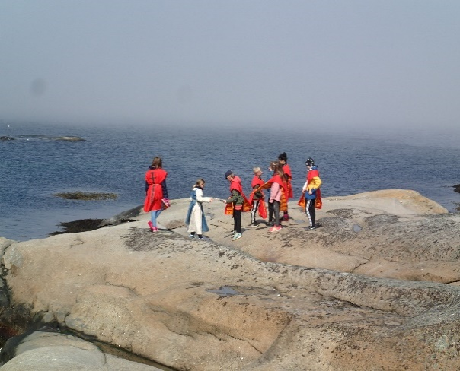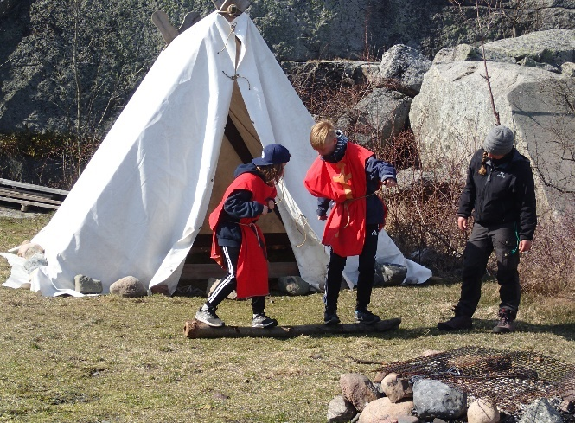

Friday: 20.04.2018 and 27.04.2018

Friday in Kruge school is for the exam day. First, they took the morning bath as daily activity. I always went back every weekday in the practice weeks, but I overnighted only every Thursday in those two weeks to take the morning bath together. Second, the kids needed to clean up the school and their cabins themselves. We, practice students also took part in the cleaning with kids. For example, kayaks, canoes, a dry room, aquariums and equipment. Thirdly, the kids made small groups with 5-6 people and participated in the Sum-up exam after breakfast. The question papers were hung on the tree in the forest behind a nature guide office. Those questions were related to what they did in their week. For example, marine lives, Vikings history, geology and geography. They handed in their own answer papers to Eric and Paal and both guides checked them. After exam. Finally, a nature guide and kids made speeches, and we gave the kids the certificates about the morning bath. We wrote down their names and the number of times they participated in the bath in the week. In addition to those two items, I wrote“愛 (Love) ”down on the card because Eric and Paal asked me to write down Japanese words and letters to make it unique. After last 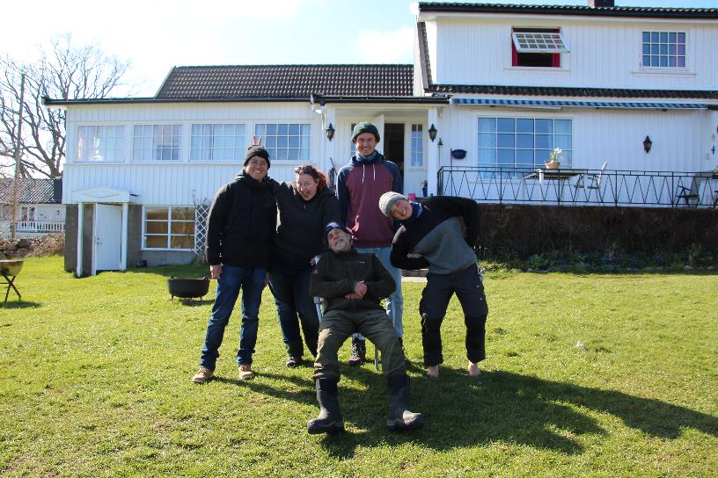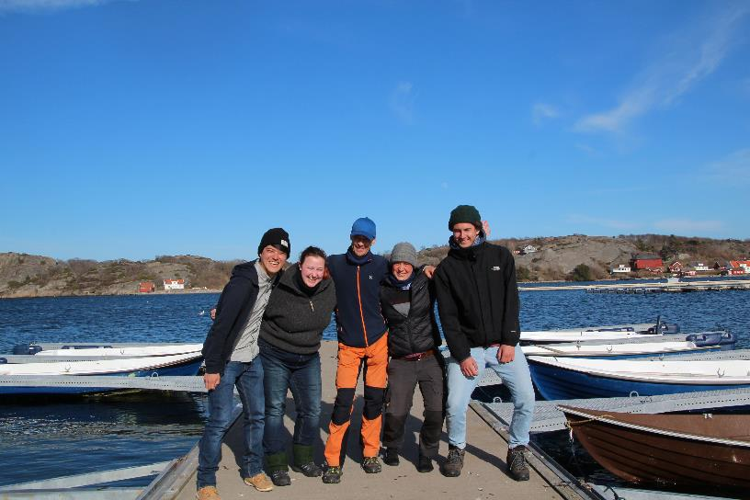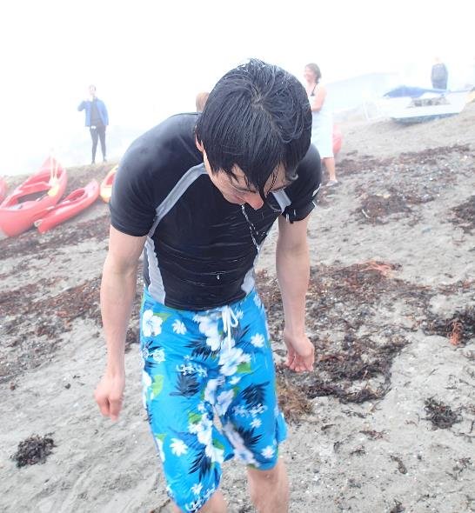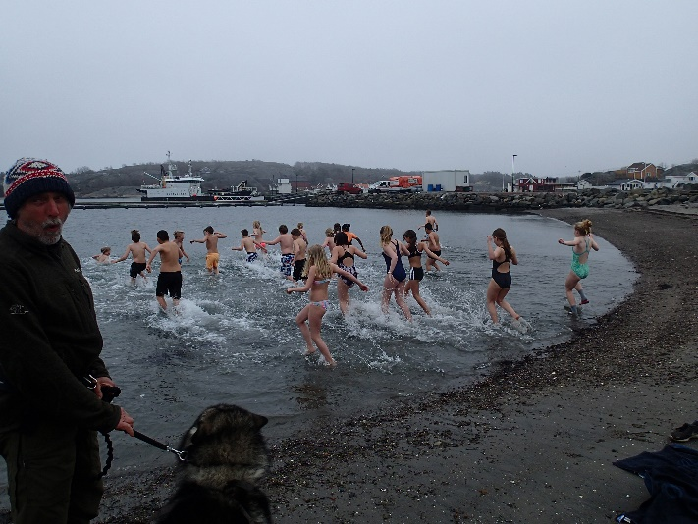meeting, the kids loaded their luggage on the bus and departed for their cities.