My Nature Area

Hikaru Wada

My Nature Area is the bush along the main road in front of my flat.

There are three trees, and paved walking road under the snow in the picture.

Week 9

I am looking forward to observing what will happen in this spring semester. I have no idea for what kind of tree I will keep attention to so far. But, the wood surface looks like cherry blossoms I watched every spring in Japan.

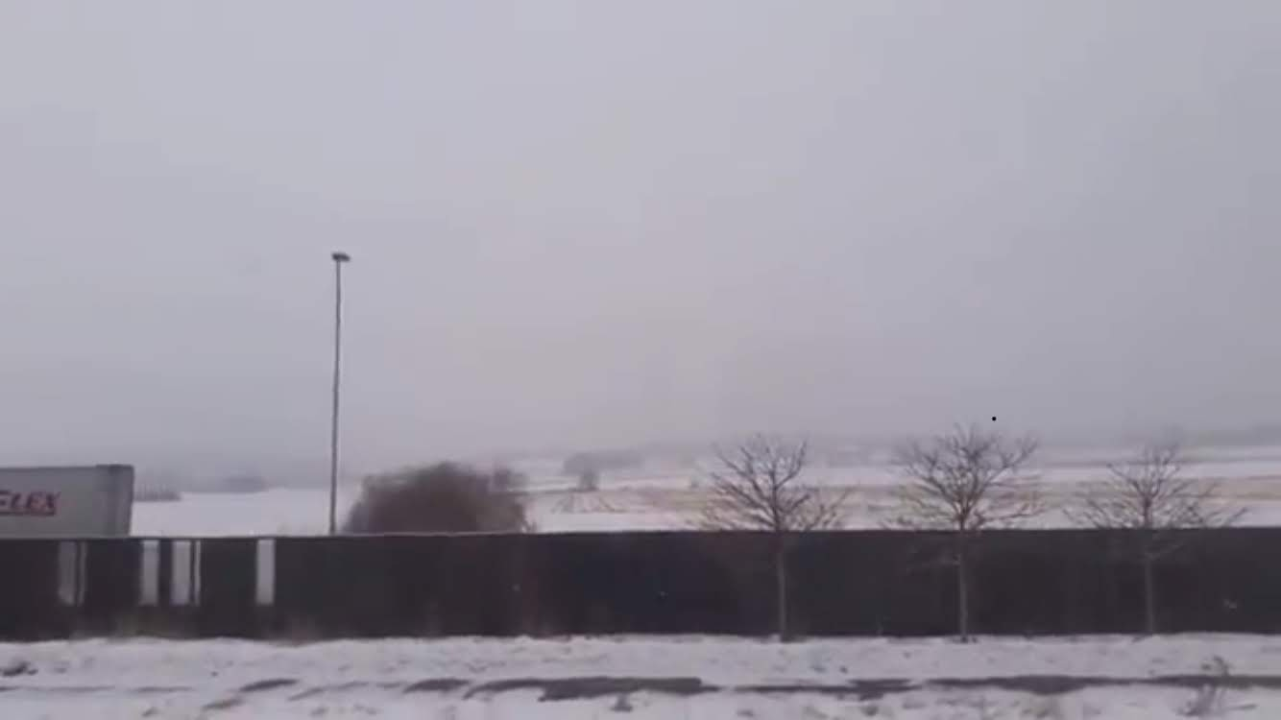

Week 11

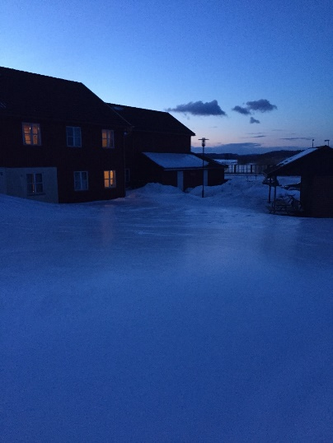The field has been covered with a lot of snow and ice. I tried to find some differences from last week, but no change so far.

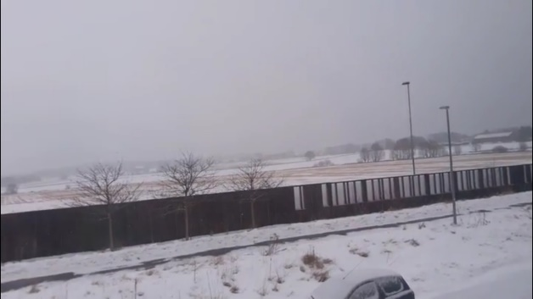

Week 14

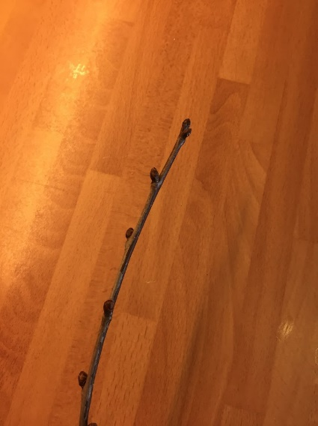The snow is getting melted. I heard from Norwegian that the snow in Norway would disappear after the Easter Week. I was so sad because I cannot find any changes. So, I decided to pick up one of branches from those tresses.

I guessed the tree was budding, but it was not the time to come out.

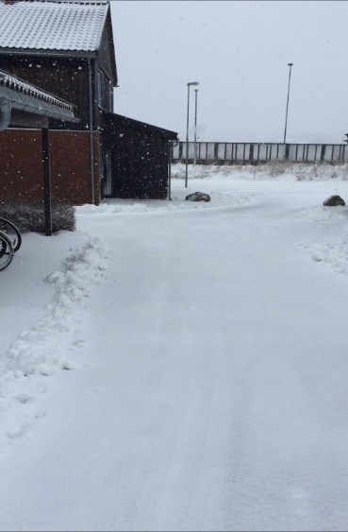

Week 16 &Week 17 (Practice weeks in Tjome)

Week 18

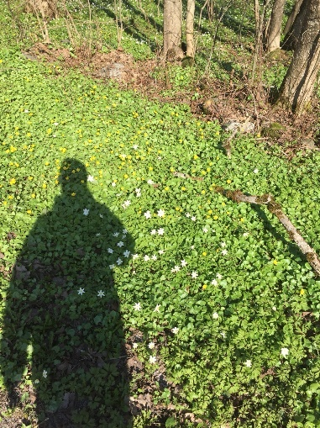On the way back to my flat, I walked down from our university to Borre. I found small white and yellow flowers blooming already. The place I took the photo below had similar environment like my nature area, because both of areas was just along to paved walking road beside main big roads. But, I did not find those blooming flowers yet. I considered the factor to make both of places different. I think the solar direction is one of the most important factors. The board behind my nature area made shadow.

Week 20

They stared blooming finally. I searched those tree on the Internet. I guessed those trees are the family of *Prunus Domestica.* I found my nature area covered with a lot of yellow dandelions as well as I took a picture in week 18. I should have checked my nature area more carefully in week 19, because the progress of blooming of the tree was much faster than I expected. That was my fail.

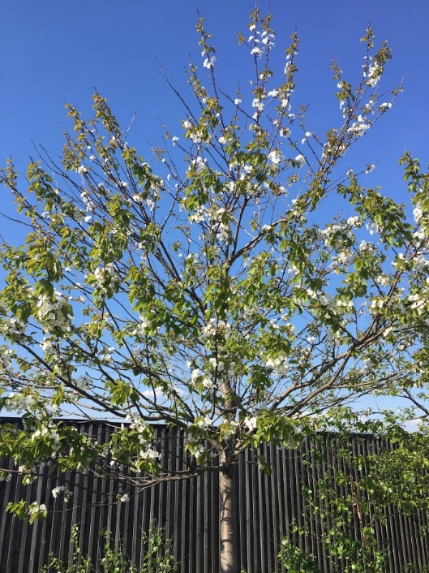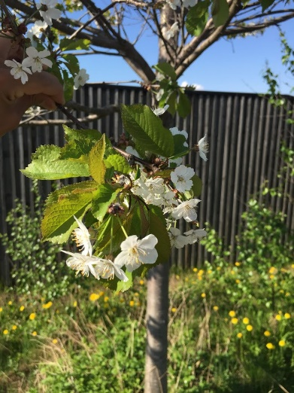

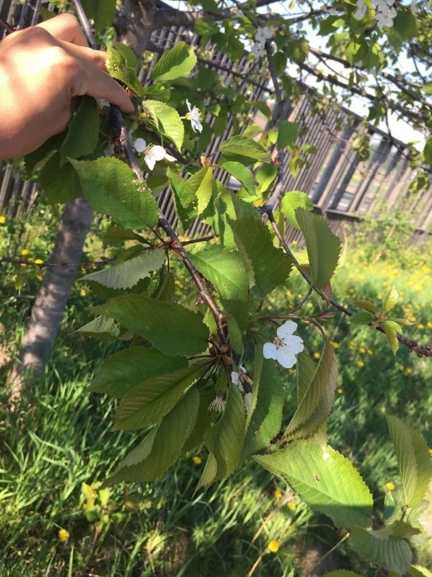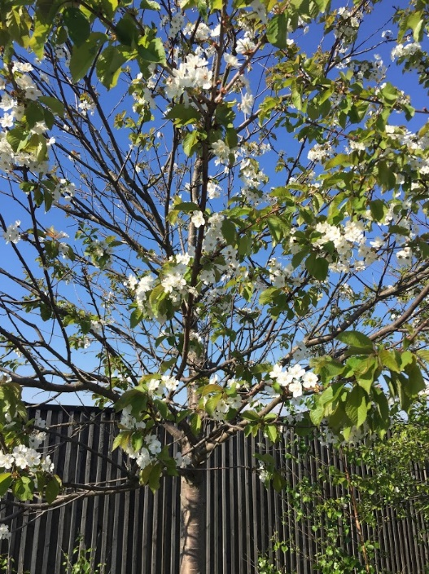

Week 21

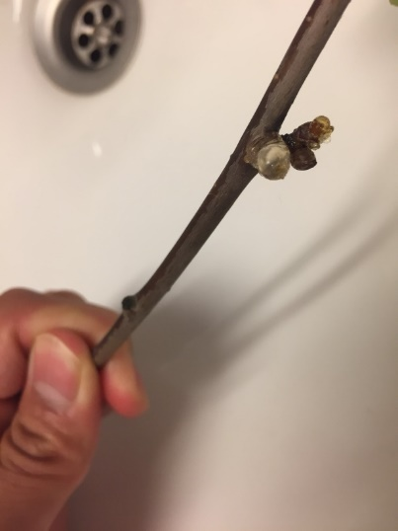At the beginning of the week, the tree still had some flowers on the branches, but most of branches had only green leaves. There were other buds for next year on the tree already. Before I stared my nature area project, all of the buds on the treee would bloom at the same season. Those other buds were a part of my new discovery. In additon to those changes on the trees, I found one curious solid material on the bud. I guess it is a part of their sap. But I also wander why they appeared after they left flowers. Their sap was only it on the tree I have observed. Under the trees, there were a lot of white fluff dandelions. Those dandelions remainded me of my youth days. I always looked for them to blow out.

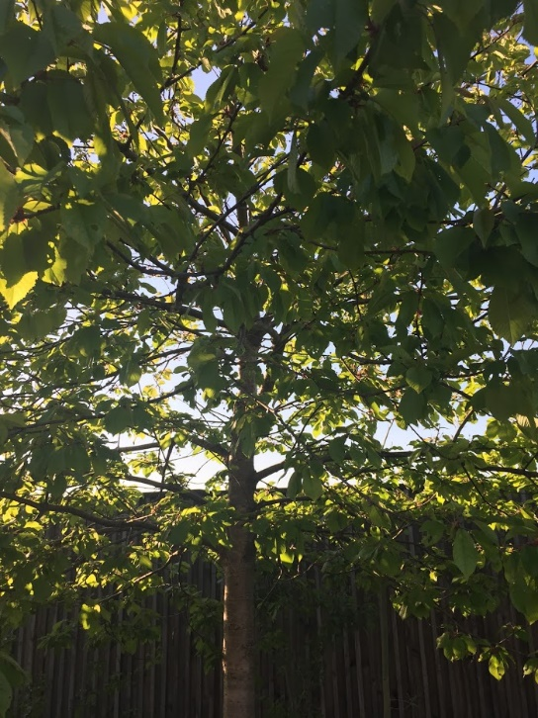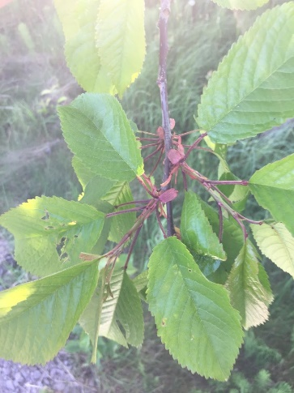

Through my nature area project…

I realized the best week of enjoying those beatiful flowers was only the last week 20. Those tree have been prepared to bloom and flowlish their own species through a long and tough Nowegian winter. Of course, I would like to enjoy observing their flowers more acutually, but I am glad to feel the low of nature through my nature area observation.

While, I have two negative points in this observatin. First, I missed the most dramatic week 19. I thought I could observe those trees like Japanese cherry blossoms. Japanese chreey takes more days to bloom out perfectly from my experience, but the weather in norway was quite unique and different from Japanese climate. I should have considered weather types for example, daylight hours, humidity and tempratures. Second, I should have taken pictures of tree from same place and angle to compare trees in each week. I tried to find differences from pictures and to write them down here, but sometimes I confused week 20 with week 21. If I take pictures of flowers and leaves from same angle like two pictures below, I could have found better differences and more impressive discoveries.(Left: the first and last week for my nature project)

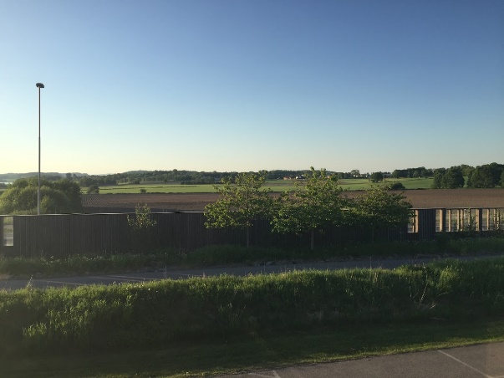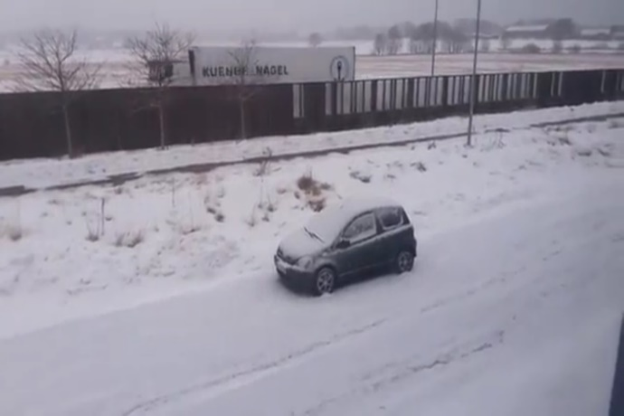

My nature project was the great experience to improve Japanese Outdoor Education, because I have never observed a single material for such a long time in my Japanese school life. When I introduce this method to Japanese school as a teacher, I want my students to enjoy and to learn more effective observations through my lecture based on this project.