Outdoor Education and Experiential Learning 2018

Assignment 1, 2018 OEEL Week 8
Placebased – learning and affordance
of a landscape

Written by Hikaru WADA

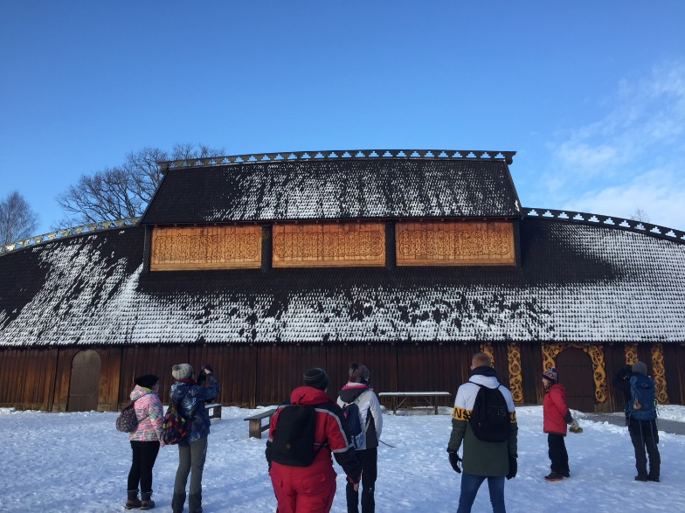

INDEX
- Introduction
- Short Definition of Outdoor Educational Terms
  - Place-based Learning
  - Risky Play
  - Curious Play
- Affordance of Outdoor Education in the Excursion
  - Our Excursion Information
  - My Affordance as an Educator
- Examples of Activities in Japanese Landscape and Nature
4.1 Main Nature Places for Japanese children
4.2 Outdoor Activities for Japanese children
- Bibliography and References

- Introduction
The purpose of this assignment is to summarize and clarify what I learned in the Norwegian outdoor and experiential activities. We have been to some excursions with Kari-Anne in Week 5 and 6. Every excursion is new experience for me to explore the places covered with a lot of snow. The places we visited were much more impressive than the city I live because my city is filled with a lot of modern buildings and architectures. It is difficult for Japanese children to find nature like where we went as excursions. The Norwegian nature inspires foreigners and Norwegian children.
This assignment first defines what I saw affordance as an Educator. Secondly, it then points out outdoor educational activities in Japan with examples. Thirdly, I mention the considerations in Norway and Japan when groups work out from school. We can find similarities and differences between both of two countries
- Short Definitions of Outdoor Educational Terms
  - Place-based Learning
Before we move to main parts of this assignment, I would like to define instantly three terms, Place-based learning, Risky play and Curious play. Place-based learning is to provide opportunities to connect learners to their own local areas for children especially. For example, connections to unique environments, culture and history in the place surrounding learners.
  - Risky Play
Let’s move on risky play. Risky play in nature can be defined as challenge and thrilling activities for children. They can measure their own abilities and what is safe or not for them. For instance, jumping down, across and climbing. In addition, Helen Tovey (2007, p99) states follows:
• attempting something never done before;
• feeling on the borderlines of ‘ out of control ’ often because of height or speed;
• overcoming fear (Stephenson 2003: 36).

  - Curious Play
At last, I mention curious play definition. Curious play in nature is a framework as self-management in natural surroundings. This play is to deliver motivation playing freely. Furthermore, curious play is more sustainable than risky play. (Kirsti Pedersen Gurholt and Jostein Rønning Sanderud, 2016) Curios play also has important role to indicate the entrance of natural science.
- Affordance of Outdoor Education in the Excursion
  - Our Excursion Information
We went to three excursions in both of week 5 and 6. I want to chose the last excursion on the 7th of February. Students of OEEL and Kari-Anne met together in front of Borre church at 08:30. We went to Borre National Park and walk along European costal path. After arriving at the Borre beach, we made fire and cook soup there. At last, we are divided into three groups and make some games, songs and stories related to natural surroundings for kids.
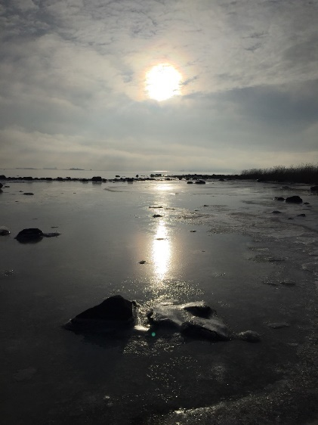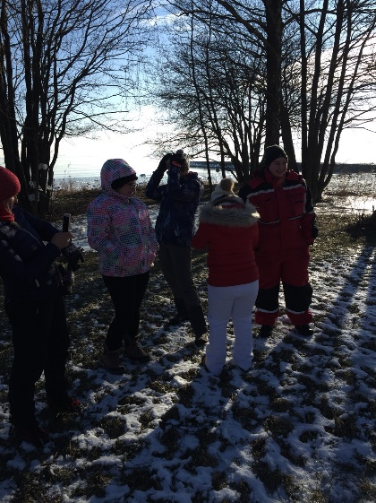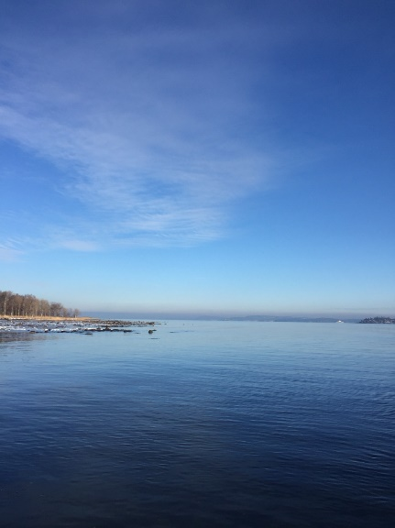
  - My Affordance as an Educator
I found two affordances in the excursion on Borre beach and the national park. One was crunchy snow sound. The sound from the foot caused me to make more sound and noise. I believe children feel that as well. I also heard this crispy sound from frozen puddles. All of boys in this course were crazy about breaking those ice. Those kinds of ice were found on the sea. I threw big stones on it, but the ice did not break out and the stones was rolling out. The other is fresh snow surface. When we were walking through the old historical hills area, we could fine fresh snow. Those fresh snow was like a canvas. I wanted to make new foot prints and write some massages down for strangers.
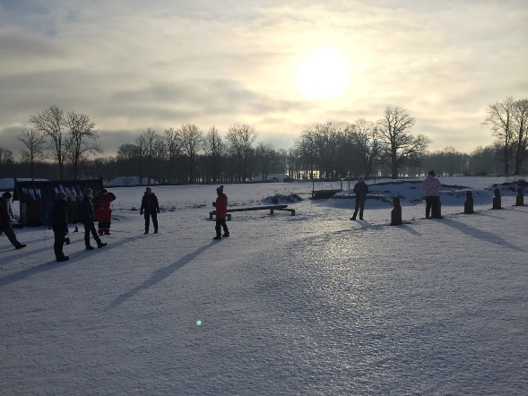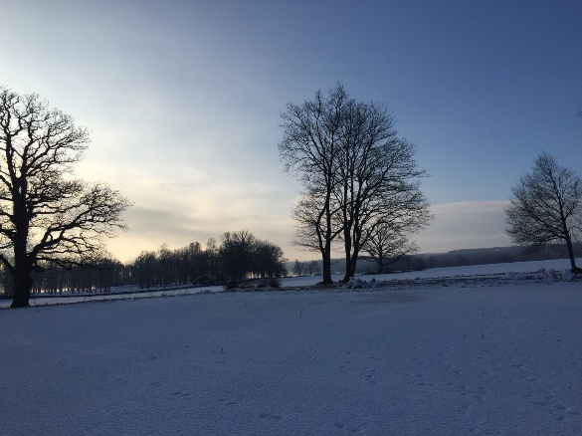
- Examples of Activities in Japanese Landscape and Nature
4.1Main Nature Places for Japanese Children
The main places where Japanese children play are parks and school playgrounds in ordinary life. Primary students (6-12 years old) can stay and play at school playground afterschool. For example, in my primary school, students played there still at 16:00 in winter season and at 16:30 in summer season. Teachers put music on around the time I mentioned above at my school. The music indicated that students had to prepare for going home and leave there. In my opinion, those school play grounds should be called artificial nature like the garden Keitaro ITO, a Japanese lecturer from Kyushu Institute of Technology, showed to us.
When it comes to real nature for children, other places they can play in natural surroundings are campsites. Most of those campsites are parts of National park and located at the countryside. People enjoy the nature life through fishing, tracking making fire and camping. Children go there as a family trips or school trips to escape from the hustle and bustle of a city.
4.2Outdoor Activities for Japanese Children
I explain outdoor activities for Japanese children with four examples, afterschool plays, Kei-doro (cops and robbers), Kan-keri (Kick and run), and Color Tags. Afterschool ply need artificial play equipment, but you can play the others without human-made exercise toys.
First, I introduce outdoor afterschool play at school playgrounds and small parks in the cities. Children play with play equipment, for example swings, jungle gyms and monkey bars. This outdoor play is classified in risky play. Children need to conquer their own fear and manage their physical abilities. On the other hand, they can also play without equipment. For instance, they play Kei-doro (Cops and Robbers), Kan-keri (Kick and Run) and Color Tags.
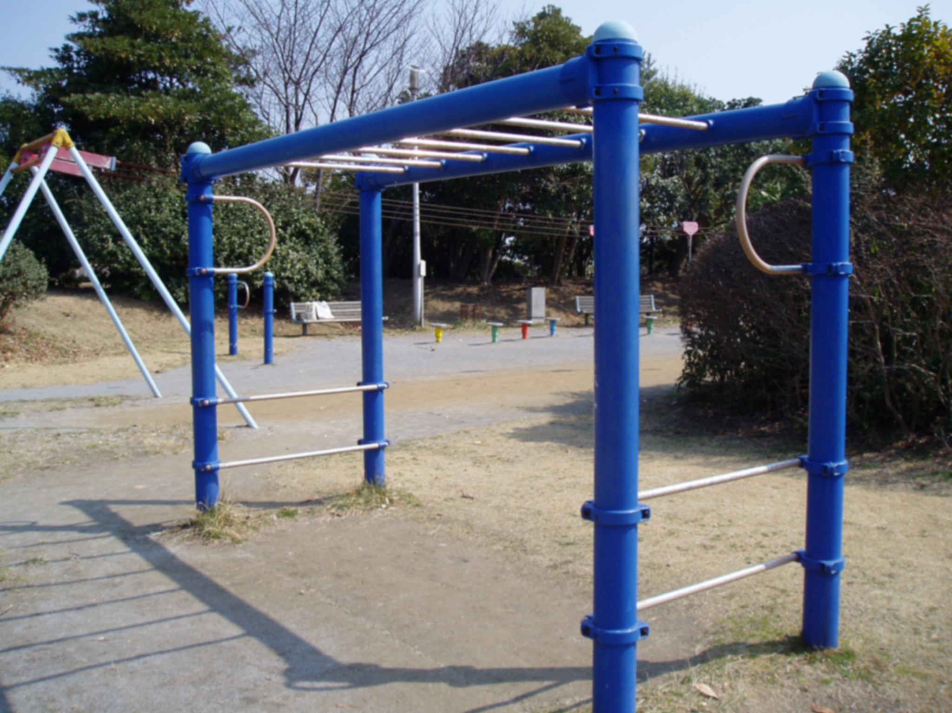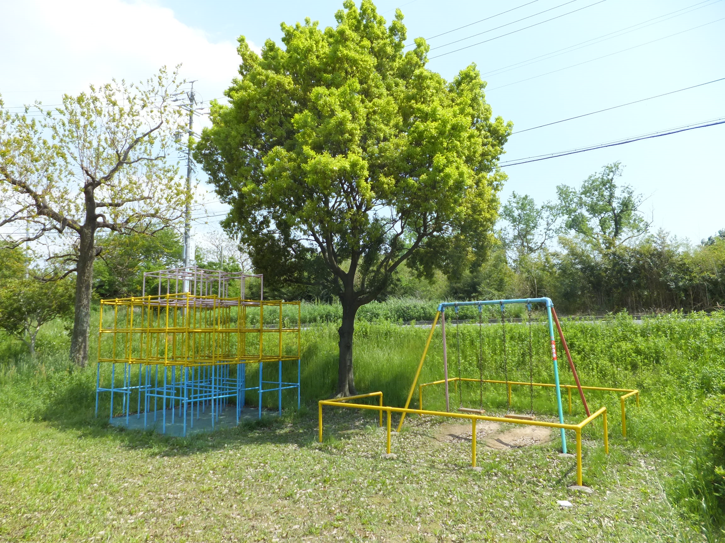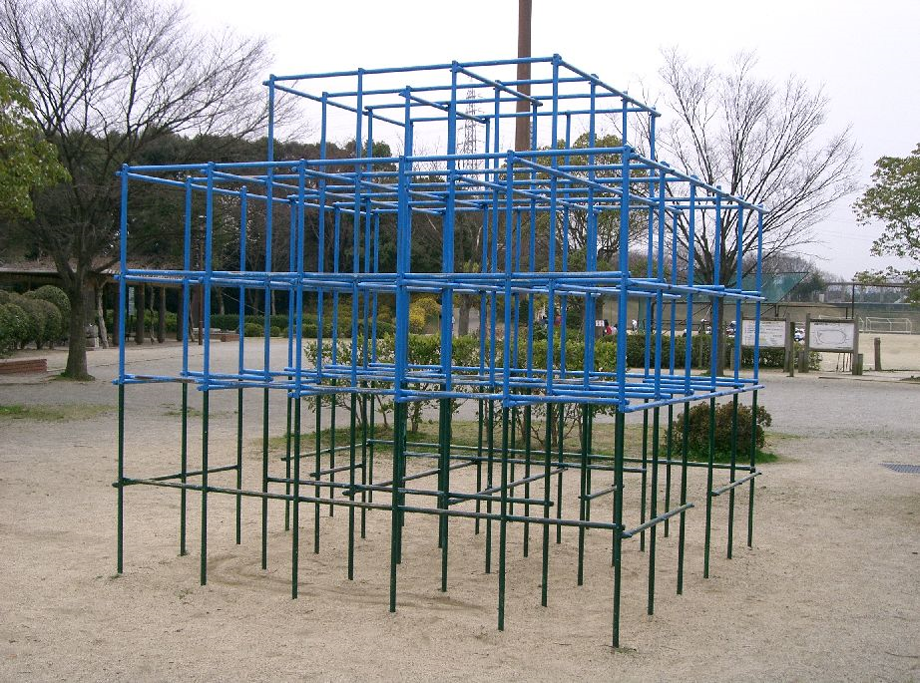
Kei-doro is a kind of tags. Children have two rolls, cops and robbers. Cops seek robbers to capture all of them. Arrested robbers can escape from a jail when one of robber touched them. This play makes both of two groups plan their own game strategies. Next is Kan-keri (Kick and Run). It's a kind of hide and seek game. The rule is a quite simple. One child plays a role as a hunter. He needs to protect the can from other players. He also should find the hiding players aiming for kicking the can. He shouts the hiding players’ name and put his feet on the top of the can when he finds them. The seeker needs to handle the maloti-task finding them and protecting the can as a same time. All of players acquire how to measure speed and the distance they can run at a certain period.
- Bibliography and References
Helen, Tovey. (2007). Playing Outdoor: Space and Places, Risk and Challenge. Retrieved February 22, 2018, from https://ebookcentral.proquest.com/lib/ucsn-ebooks/reader.action?docID=332733&query=
Kirsti Pedersen Gurholt & Jostein Rønning Sanderud. (April,2016) Curious play: children’s exploration of nature, Journal of Adventure Education and Outdoor Learning. Retrieved February 22, 2018, from http://www.tandfonline.com/doi/full/10.1080/14729679.2016.1162183

