**Outdoor Education and Experiential Learning 2018**

**Assignment 2, 2018 OEEL**

**My Winter Experience,**

**27th of February - 1st of March**

Written by Hikaru WADA

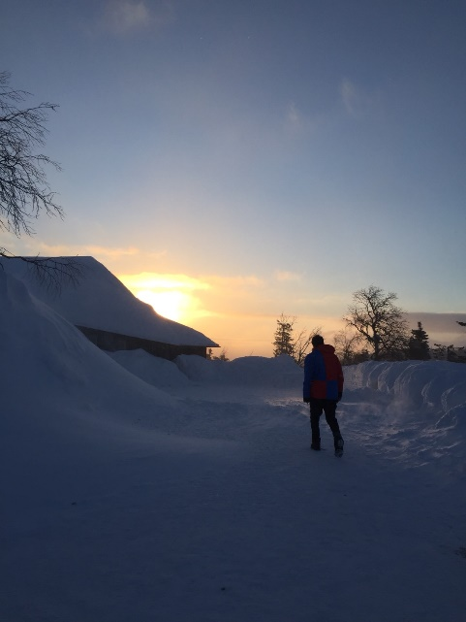

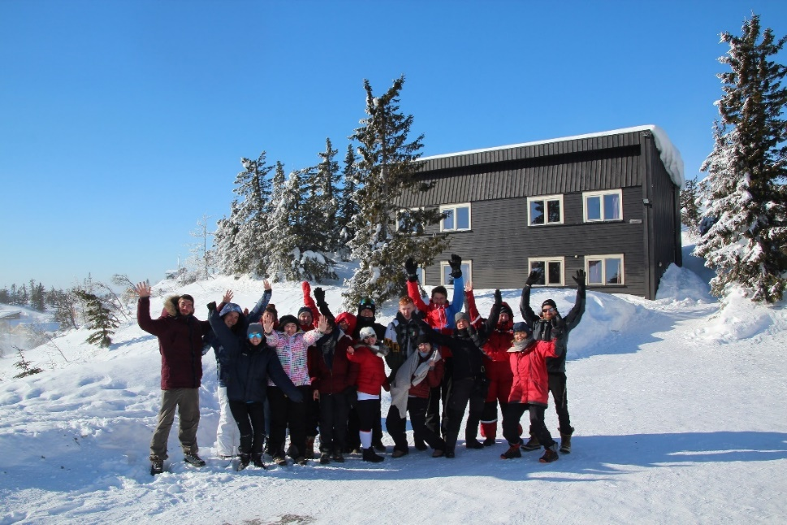



**INDEX**

1. **Introduction**
2. **My Winter Experience**

**2.1 Basic Information about Our Trip**

**2.2 My Experience and Recapitulation**

1. **My Invitation Letter to Japanese Schools**

**3.1 The size of Group and The Age of Children**

**3.2 Time Table and Activity Plans in Winter Excursion**

**4. References**

1. **Introduction**

The purpose of this assignment is to clarify and summarize the personal feedback and what I learned in OEEL 2018 winter excursion in Telemark. This assignment is structured by one introduction and two chapters, My winter Experience and My Invitation Letter to Japanese School. Firstly, I mention that What I experienced in this winter excursion. I acquired skills to manage the groups in the winter mountains because I belonged to the intermediate group. Secondly, this assignment shows my invitation letters to Japanese teachers who they are going to come to this area with Japanese students as a short school trip. I write down important information to carry out the school trip successfully.

1. **My Winter Experience**
   1. **Basic Information about Our Trip**

OEEL Winter Excursion was carried out on 27th of February – 1st of March 2018. The first day, we left Bakkenteigen for Jonnbu, Lifjell at 8:30 and arrived there two hours later. The first day was really windy, and blinding blizzard raged. We explored Bo area all together, but the day was hard and tough for beginners like Spanish girls, and they struggled to go forward in the storm.

The second day, the weather was nice and perfect for outdoor activity. We were divided into two groups, beginners and intermediators. The first group learned basic skills to ski down and up hills with cross country style. The second group I belonged to learned how to ski without poles and also to check the plied snow condition for building up base camps with Andreas. After the lecture about natural factors to snow mountain environments, we explored and cross-country skied hills those area with Kari- Anne for two hours approximately.

The third day, we continued group activities, beginners and intermediators. Beginners skilled up their own skiing and we, intermediators with Andreas, practiced the coordinates in the mountain with the bearing numbers on maps. We next went down hills with Kari-Anne shorter than the second day. Finally,we came back to Horten at 13:30.

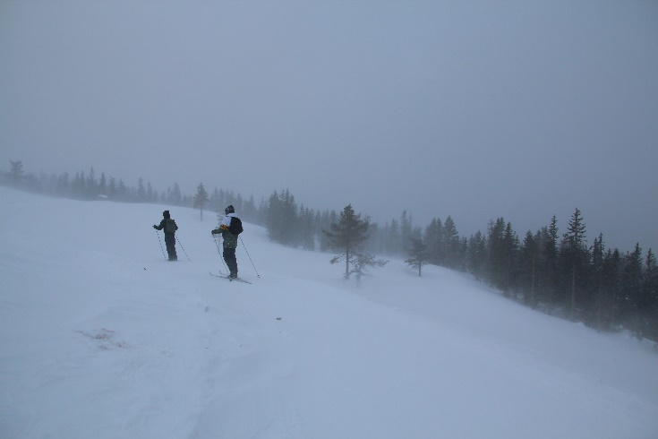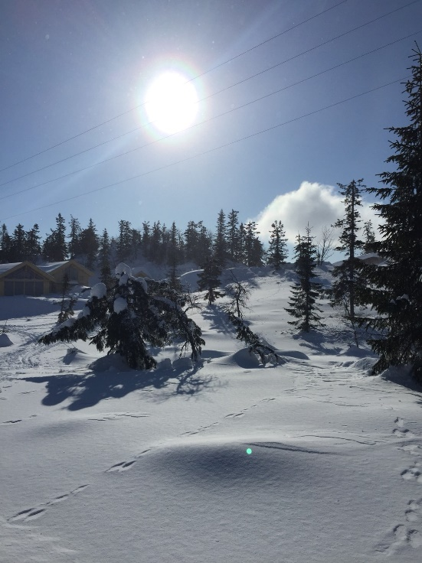**Pictures: Weather Differences Between↑ The First Day and The Second Day　→**

* 1. **My Experience and Recapitulation**

The aim of this part is to analyze what I experienced in detail in the excursion. I already wrote the time series information briefly above. In addition to those information, I mention two experiences I was interested in through lectures and winter outdoor activities there in this part. One is the induvial behaviors. The other is importance of winter equipment.

Firstly, I strongly realize our own nationality characters and behaviors in the excursion. We were composed of six nationalities, Norway, Denmark, Spain, Germany, Ireland and Japan. I found the differences among our nationalities when we organized our dinner. I felt that Norwegian and Danish tried to be neutral. The reason why I think so is that they spoke English and to communicate individuals as equally as they can although those Scandinavians can understand each other in their own languages. On the other hand, Spanish talked each other in their own language. While our cooking and after the dinner, they sang songs and danced to make good atmosphere. When it comes to German, they worked hard and were very industrial. They cleaned dishes and our kitchen as possible as they can. Finally, Irish is very open-minded. He talked to us a lot friendly.

Secondly, I could feel the importance of equipment in the mountain. Kari-Anne told us what we should bring to the mountain and what we should wear there in the lecture on 26th of February. At that time, over half of students in our course could not take the lecture accidentally because of their traffic issues. I saw them having problems outside because they did not prepare for the trip well. For example, one of them did not bring sunglass. The others did not prepare spare gloves and mittens. In the excursion, those problems did not cause serious accidents to them because the lecturer, Kari-Anne and Andreas brought a plenty of helpful tools and equipment for us. But we are going to be teachers and we will need to take responsibility on the student security.

1. **My Invitation Letter to Japanese Schools**
   1. **The size of Group and The Age of Children**

At the beginning, I assume the size of group and the age of children from Japan. In Japan, outdoor excursions are curried out with the specific grade students. I also estimate that 2 classes of 6th grade primary school students (they are 11-12years old. Each class has 30 students.) would come to the mountain with 6 teachers (2 main teachers and 3 sub-teachers and 1 school physician). They would stay 4 days 3 nights there. In addition to those 6 teachers, we will invite Andreas as a technical adviser.

* 1. **The Activity Plan Table in the Excursion**

|  |  |  |  |
| --- | --- | --- | --- |
|  | **Morning** | **Afternoon** | **Evening** |
| **Day1** | **Arrival:10.30**  **Basic Information from Andreas**  **Coordinates and compass skills** | **After lunch:13.00**  **Dressing up for Outdoor Activity**  **14.00 Students skill test**  **17.00 coming back** | **dinner: 18:00-19.00**  **after dinner**  **An announcement for grouping**  **Shower and light out** |
| **Day2** | **After breakfast:10.00**  **Group Ice-break play** | **After lunch:13.00**  **Group Outdoor Activity 1**  **Group Outdoor Activity 2** | **Dinner: 18:00-19.00**  **After dinner**  **Feedback today** |
| **Day3** | **After breakfast:10.00**  **Group Ice-break play**  **Making the group purpose** | **After lunch:13.00**  **Group Outdoor Activity 3**  **Special Break**  **Making Fire at the outside shelter** | **Dinner: 18:00-19.00**  **After dinner**  **Feedback of the trip**  **Group discussion**  **and Short group speech**  **Shower and light out** |
| **Day4** | **Departure:12.00** |  |  |

* 1. **The Purpose of Each Activity**

First, students take the lecture from Andreas. They acquire the skills to read maps and coordinates with bearing numbers. It is helpful for students to come back to the main base camp at the church. After that, they take the skill challenge test and, teachers divided the students into 4 groups on Day1. Two groups are beginners and the other two groups are intermediators. (15 students each approximately) In the evening on Day1, students decide the two leaders and two vise leaders. Also, they make their own buddy to check up their condition during the outdoor activity. In the grouping, they learn how to check up the body condition and how body work to keep up the warmness following the website, ‘Outdoor Action’. Teachers let them know what affects your core body temperature. Outdoor Action which Kari-Anne showed us in the lecture mentions ‘Cold Challenge’ and ‘Conditions Leading to Hypothermia’. Teachers should summarize them and let students understand those systems.

On the Day2, each group has Ice- break plays in the morning. For example, Crowding and Pulling and People Chair. Those activities make the students worm before going out and they are encouraged to go out with positive minds. Also they should unite in those game and, they need to cheer themselves up. Those games help them to build up their copulation in the excursion. The main outdoor activity in the afternoon on Day2 and Day3 are to skill up their ability in the winter mountain. For beginner groups, teachers lead them to go down and climb up the small hills with fundamental skills. For experienced groups, teachers and Andreas spread the papers with letter keys and those groups try to find them with coordinates system.

←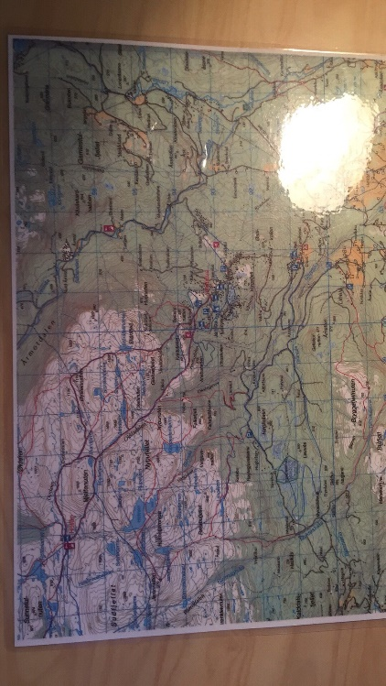the map we used for coordination system

**4. References**

**‘Outdoor Action’ / 10.03.2018 https://www.princeton.edu/~oa/safety/hypocold.shtml**