**Our visit to Tønsberg**

On Tuesday 29th, August, our group: Hikaru, Adrian and Lara, went to explore Tønsberg, the oldest city in Norway. We tried to focus our exploration in education and cultural issues, since it is impossible to get to know everything that a city has in just one visit. We compare three cities, Valencia in Spain, Osaka in Japan and Tonsberg in Norway.

The first thing that we noticed was that the streets were older and paved in rock. This is something that shocked us since in our home countries the cities have a different style, more modern.

Also, despite being one of the major cities of Norway, for us it looked more like a village rather than like a city. This is because there were too many houses and very little flats, whereas in Spain, the cities are normally built up and surrounded by flats. Besides, due to the amount of vegetation around the city, it reminded us more to the countryside of our respective homelands. In Japan, most of our roads is mostly paved by asphalt and the color of the roads is darker than the roads in Tønsberg. Japanese road pavement is totally different from Europe countries. We don’t get to see that much trees and vegetation in our homelands, at least not in urban areas.

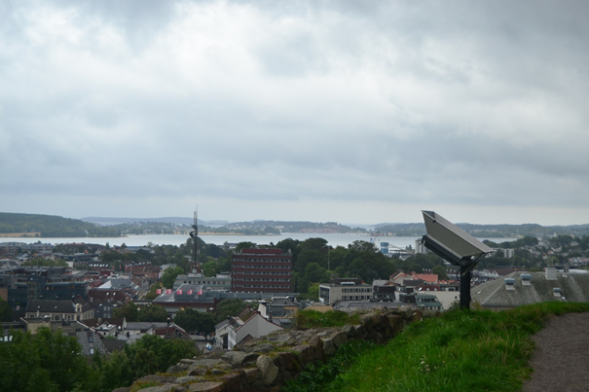

This facts led us to think that in Norway and its culture, they have more into account and value most nature and the memory of their ancestors.One of the first things that we have seen is the castle. It has a lot of importance in the city since the identity symbol of the city.

The ruins of the castle of Tønsberg are an emblematic part of the city, being the identity symbol of it. Even in the flag you can see the castle itself. This old castle seemed to have some importance, it is even a little museum which you can visit and tells about the history, not only of the castle, but also of the city of Tønsberg. This means that both the city and its castle are close and one depends on the other. Despite being the tower the only part remaining of the castle, the ruins are still there (we even saw and excavation going on in one part of the ruins), and they are properly cared of.

We concluded that Norway is a country where historical memory is present, and not forgotten or left behind; the symbols of the cities and the past are still there, and are also an attraction for people visiting the place. This also happens in our countries, where maybe we don`t give that much attention to historical memory, but still, we consider it, and it is a touristy attraction. Truth be told, in Spain and Japan, at least, some monuments or places are not cared of the way they really should, since are valuable and old, and sometimes we are regarded by foreigners as careless or not too into our history. Nevertheless, we still consider our history and it is still visible in our cities nowadays, we even get thousands of visitors from all around the globe who come to visit those places and monuments.

**Museum**

Links with the historical memory and identity of the city. Big for being a Little city’s museum with a good amount of info. In this museum, we can find some exhibitions about marine culture in Norway. Especially, Hikaru was interested in whale hunting culture there.

First, we compare it to Japan. In some area in Japan, people have hunt whales and dolphins for a long time. One of those area was focused on and filmed by the famous movie,”The Cove”. The movie is a documentary about a research for dolphin huntings in Wakayama Prefecture which is nearby Osaka Hikaru lived in. The traditional event of dolphin hunting have been held every year. In addition to the traditional huntings, the Japanese government sends research groups to the South Pole. The government allows them to hunt whales for ecological survey.

At the same time, it sells the whale meat to us after the research so the Japanese eat whale meat, but the opportunities to eat them are quite rera. Those dishes are not general meals for Japanese people. Hikaru says, “we got to eat whale dishes for Inheritance of Japanese food culture once a year in my elementary school in Osaka.”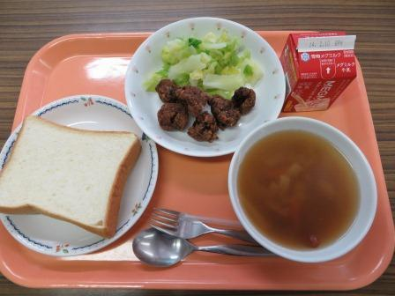21222605_1974593942820683_721471497_o.jpg

In addition to marine culture, we found a lot of space for kids in the museum. If children are too young to understand some historical stuff, they can spend a good time there. For example, there are some board games, colored pencils, coloring books and toy building blocks.

In Cantabria there is also an important culture around the sea. We have a maritime museum with a large whale as well as the one in Tønsberg, there is also a lot of history around the harbor, it had been the most important harbor in Spain, we have the replica of three boats of Cristobal Colon, and it is also in Santander where the sailing national competitions took place.

**Shopping center: culture nowadays.**

It is no surprise that globalization is a fact, and in every considerably middle-sized city, it is likely that you find a shopping center. At least, one. And so we did when we visited Tønsberg. The very first moment we got off the bus, we found one shopping center, and, needless to say, this wasn't as surprising as other things.

The center was not too different to what we are used to. Several clothing shops, some miscellanea, and food. Typical. Maybe what changes from one country to another is the style in which the center is designed, but still, it resembled to the ones in Spain and Japan, with not too many differences to point out. If it is compared to Japanese typical shopping malls, the shopping mall in Tonsberg is more bright than Japanese ones because more sunlight come in through the skylight. Perhaps this is due to the global image we have of this centers, since it isn't something specific from one country, but a shared cultural item.

**Education, kindergartens, schools.**

In our visit to Tønsberg we went to a school, we couldn't talk too much with the teachers because they were really busy, but we visited the school and we spoke also with some people about the schools in that area. What we found more surprising was that the surroundings of the schools, which in most of the cases are vegetation, fields, and nature where they can, and in fact spend, a lot of time.

Other interesting issue that we know now is the amount of schools with alternative education, such as Steiner or Montessori. Besides, this kind of education is known by the majority of the community. It is really surprising for us since in Spain and in Japan. Those alternative educational schools in Norway are much more than those kinds of schools in Spain and Japan. Only people who are interested in education, and specifically in alternative education knows that kind of schools. Also the amount of them is higher here than in our hometwons.

We spoke to a woman who told us some information about this issue. She told us that in Norway it is very common that some families don’t want their children to commute to big schools which are far away from their houses, so they build up smaller schools, which usually have alternative pedagogics.