Norway has a very high standard of living, compared to most countries and compared to Spain. It is about above the general average in employment, education, health, civic commitment and so on. In this essay, we will focus on the Norwegian lifestyle, specially in education, employment, economy and schedules. Moreover, we will talk about typical dishes that captured our attention from both countries.

1. **LIFESTYLE IN NORWAY, COMPARED TO SPAIN**

**1.1 EDUCATION, EMPLOYMENT**

On the one hand, most people in Norway have a job and it is quite easy to get it. In Spain, people used to get jobs easily. But it changed when the crisis of 2008 arrived, so that a lot of people lost their jobs. Nowadays, even though the rate of unemployment has decreased the jobs that people get, they are not well-paid and the conditions are not adequate.

On the other hand, one thing is that, from our point of view, the educative system is much better in Norway than in Spain. Norway has a high level of education and skills. For instance, it is a country very dedicated to education, and technologies are closer to children much earlier than in Spain. Besides, the number of children is roughly 13 children each class and in Spain is about 20. In Norway, there is a figure of a support teacher as well as a tutor. While in Spain there is only one teacher for all the class.

The implication of parents is more or less the same, but we think in a different way. For instance, in Norway parent’s intervention is so active and teachers invite parents to be in the schools with their sons in order to interact with them and to help them with problems they have. For parents, the figure of a teacher is very respectful due to the fact that they think that the success that children get for life is because of them. Related to Spain, the intervention is active as well and it is increasing more and more but not only for vocation, but also their quality of lives. This led to demotivation for the parents, and lately the pupils. This causes scholar failure.

Moreover, something that captured a lot our attention was the level of English that they have. They start learning English with six years old, and in last grade they can speak and understand a good range of words. In Spain, we start learning English even in kindergarten school and at the end of primary, they are not able to speak fluently, neither understand the language.

To sum up, teachers in Norway are focused on how children can learn about things of everyday life. It has high values, while in Spanish schools, they only focus on memorising things and hard knowledges.

* 1. **PRICES IN NORWAY: HIGH STANDARD OF LIVING**

Norway is considered one of the countries with the best living standards not only in Europe, but in the world. There are some facts that might explain why it has recently and quickly become a rich country, especially compared to another countries similar in size and population.

In the first place, its growing economy, which is impulse by oil, gas and petroleum. This is not only efficient and stable, but gives Norway the reassurance of being wealthy for many years to come. Furthermore, the petroleum has been one of the main exports for Norway since the 1970’s, and this business provides great sums of money.

In the second place, the rate of unemployment is really low compared to other countries, and this makes Norway really productive. Therefore, the benefits of this productivity provide Norwegian people with higher salaries. The poverty rate is really low as well, being the gap between the rich and the poor significantly small. At the same time, even though its population has been rapidly growing for the last years, it is still a little country, with 5 million inhabitants. Compared to Sweden (9’5 million), a country with more or less the same characteristics, it is quite a low population. Consequently, with more wealth due to the facts already exposed, and less population, this wealth can be distributed so as everyone can easily achieve a high standard of living.

Since Norwegian people has a high wage, their purchasing power is high too. Of course, they are to pay higher taxes, but since their salaries, as explained, are higher, this is not as bad as it happens in Spain, for example, where salaries are much lower, and taxes are too high for the wages. Thus, the prices in Norway are likely to be higher, however, for the people from Norway, they will be cheap or normal, but as it has been explained, there are several reasons for them to think so.

In conclusion, Norway is a country with a big wealth among other countries, due to several facts. The low population makes easier for them to distribute the money and gains, and these gains at the same time come from prosperous business such as oil, gas, or petroleum, but also freshwater, or salmon. All of them are stable and expensive, giving Norway a good income. Knowing this, it is no mystery why Norway has become a rich country so fast.

* 1. **DIFFERENT TIMETABLES**

Norway is not located at the same height as Spain but it has the same time zone. Although, Spain and Norway have the same times, dawn and dusk are produce at different times because of the situation on the Earth. It is possible to believe that the timetables they have for eating are due to these facts, and probably the timetables they have at work.

On the one hand, they usually start working at 8:00 am and finish at 18:00 pm whilst people in Spain start their workday at 9:00 am and finish at 20:00 pm. It important to point out that Spanish people usually have a break at lunch time for around 2 hours while Norwegians have a little break at midday for around 20 minutes.

On the other hand, Spanish people usually have dinner at 21:00 pm when most of them finishes their workday. Norwegians as a rule they have dinner at 18:00 pm, so that at 21:00 pm they usually have a snack.  It has been difficult to get used to this timetable but we have mold ours so that we could meet our Norwegian friends.

**2. TYPICAL DISHES IN SPAIN AND IN NORWAY**

Both in Norway and in Spain there are some typical dishes that are the most common in the region. They became famous due to a bad period on the history of the country, or because it is made by national products and ingredients.

One of the main specialties in Norway is the porridge which is made by oats and milk or water. It could be accompanied with some sweet or salt products such as bacon, fruit, raisins… This dish is considered one of the most known owing to a crisis period in the country so that they create this recipe made by one simple ingredient affordable for that time.

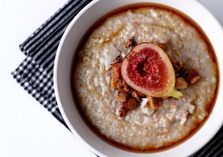 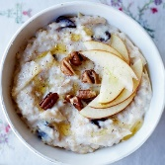

As well in Spain, there is a national dish because of a crisis period. This is the Spanish omelette made with eggs and potatoes. Those were national ingredients easy to get and cultivate, it is a cheap and nutritious food made to fight against the hunger of the time.

Although nowadays, we can find the Spanish omelette in different ways and in mostly every restaurant, but the most common and known as the first recipe had just eggs, potatoes and onion.

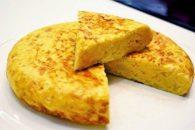 

But there are other many national plates, famous as well in the whole world and in Spain. But as it usually happens the recipe is changed and it causes different versions of the same dish. Now, we’re talking about the Valencian Paella.

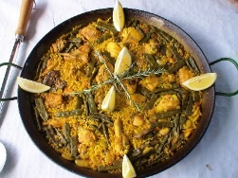

It has as main ingredients: rice, chicken, rabbit, tomato, green beans and white big beans. Also, dressed with rosemary, lemon and saffron. During the passing years, it has been changed and now you can find it with fish, paprika or mushrooms.

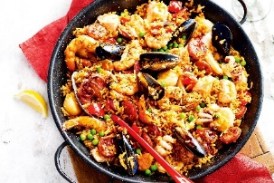 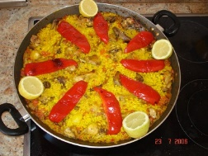 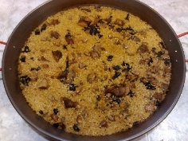

On the other hand, in Norway there is also a typical dish with meat and vegetables. In this case we talk about the Fårikål which ingredients are lamb, cabbage and pepper. These ingredients are cooked for hours and it is served with potatoes.

To conclude, we have found lots of differences between these countries, but the ones that attacked our attention were the ones related to their customs. As we have said, there are things completely different, but it has been easy to get used to this country due to the friendliness and sympathy af the people in here.