By Sarah & Eila

Where: The beach at Steinbrygga/Borre National Park. Walk the road passing by Borre Kirke down to the fjord and the harbor for small boats.

Purpose: Get familiar with various plants and animals living at a beach, both in water and on shore. Training in How to do excursions with children.

What is a beach: A beach is a borderline between dry land and the ocean. The area is affected by various environmental factors specific for this area, specially the regular changing between wet and dry conditions. Beaches are of various types: exposed or protected area, hard or soft bottom, depending on dominating abiotic factors.

Organizing: Split in groups of 3-4 persons. Each group work on a specific destination/posts for 1 hour. Thereafter change posts.

Equipment: White plastic bucks, spades, sieves, tweezers, plastic aquariums, glass bottles, microscopes, field handbooks, fishing net.

Post 1: Plants and animals on a sandy beach: We decided to also try out the crab lace and lobster trap made out of a plastic bottle. None of these two were successful for our group, however another group managed to catch a crab.

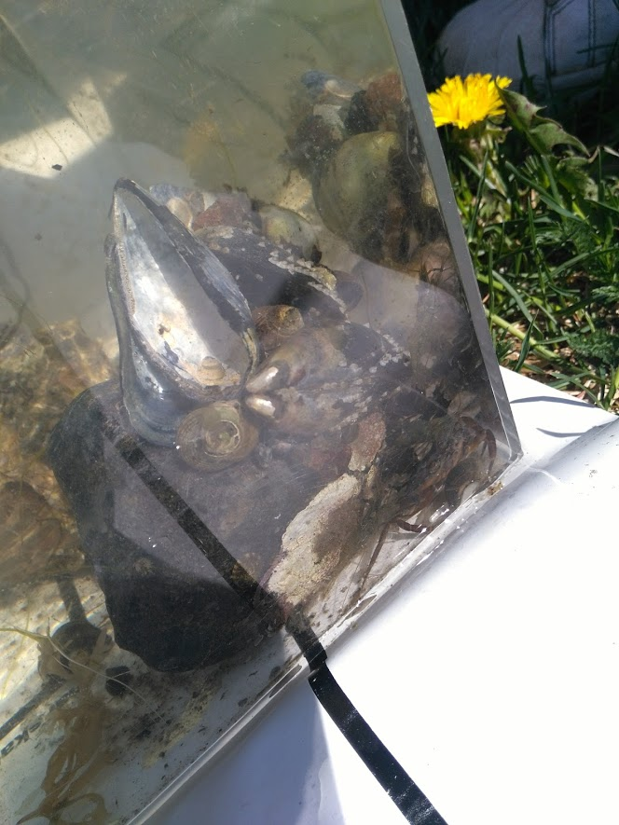
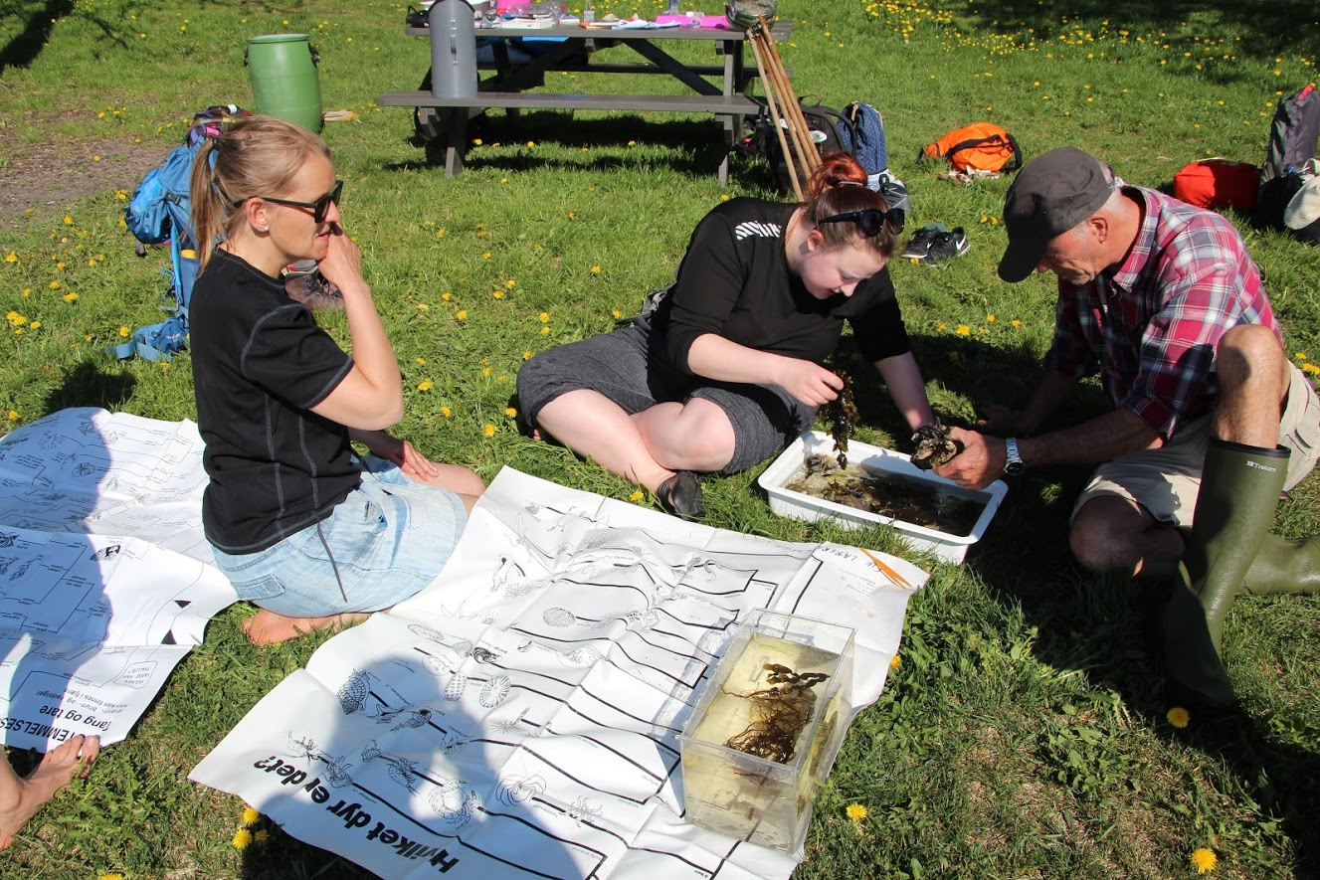

Post 2:Fish: Fish net was descended into the water by two to four people, and it was dragged both along the bottom of the sea bed as well as along the water surface. The purpose was to collect as many species as possible and drag them towards the beach where the net would be examined and emptied.
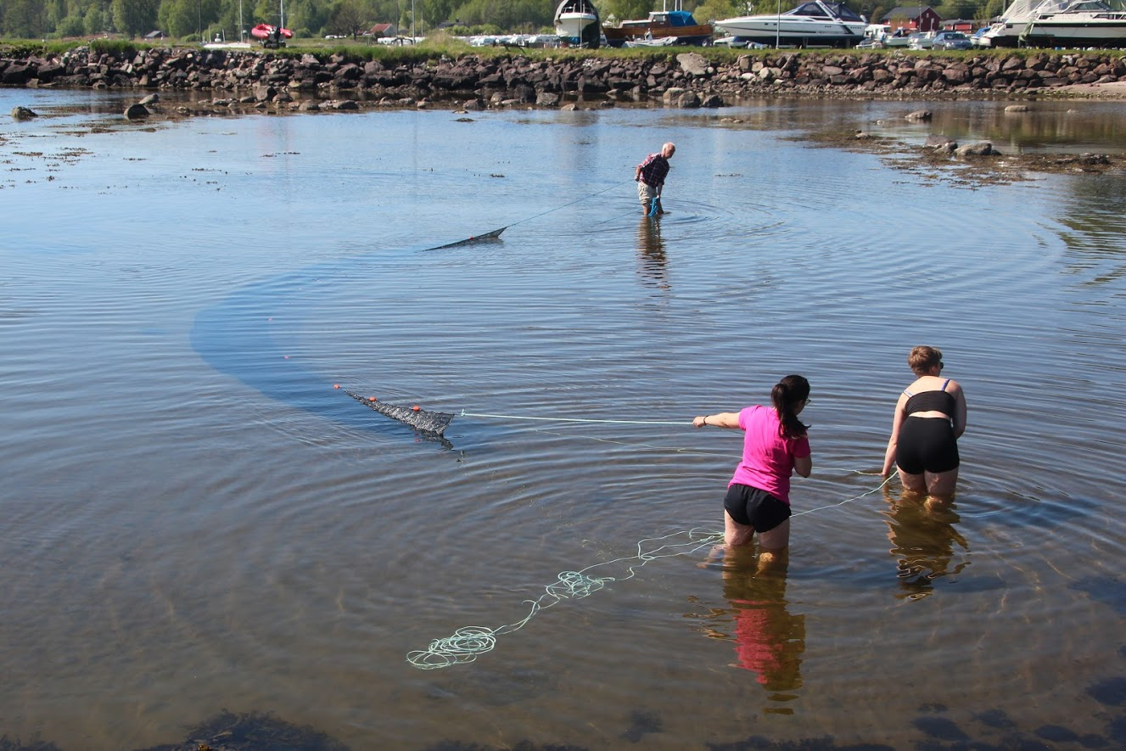

Post 3: Plants on shore:The area from the ocean to dry land was divided into zones defined by the domination of certain plant species. Each zone is subject to specific environmental factors. We tried to define these zones which were characterized by certain plant species. We also tried to find out which environmental factors that could be important for creating these zones, like tide, waves, wind, ground consistence (sand, rock, mud) deposits from the sea, humidity and sunlight. We were to try to draw a map.

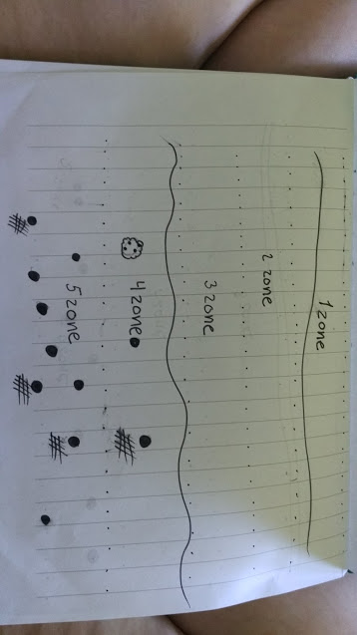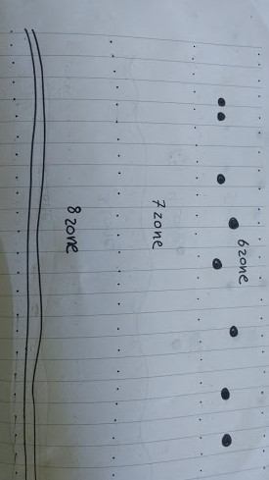

1 Zone:
Influential factors: Tides, waves, location in a fjord and thereby relativ shealtered. Observations and thoughts: the sand is finely grained and there is not many stones, so we think that the beach here doesn't get that high waves.
2 Zone: “dead zone” dead algaes are dominating this area, and therefore we think this might be an area where the sea sometimes go up, but not that often so maybe in high tide?
3 Zone: No more seawater, and if seawater only with storm and high waves and splashes.
sporadically appearing land plants. Ground is mostly sand, and the plants have short roots to thrive in sand, some Dune grass which implies that by then there is no more seawater by waves.
4 Zone a small incline in hight and after this normal plants appear. Normal grass, dandelions in full bloom and a couple of trees and bushes. we believe there might be a difference in soil components or ph level between zone 4 and 5 since the vegetation differs with species of plants and amount of trees and bushes.
5 Zone:Many trees in this area, that with there leaves make shadow in the summer. Lots of plants fx: clovers, wood anemones, blåveis, buttercups. All of these flowers are most usually found in ground that are alkaline.
6 Zone:”Snowmelt area?” the ground decline a bit from the rest of the area and seems dead. Is this because of all the water left over from the snow, and thereby hindering plants growth? Or has some kind of human impact done this.
7 Zone: Dense forest area with a least 4 different tree species, such as birch and beech and a lot of bushes.
8 Zone:Less dense forest with more air. A man made stone fence stops the area. More flowers and less bushes.

Post 4: Curiosities:We made a collection of “curiosities” that we had found, and laid it all on the grass. Then we had to explain to the class why we had chosen the different items and discuss whether or not children would have chosen the same items as us. We found some different things, for example a blue colored rock, a boiled crab shell, a garden hose with something grown onto the end, cones from a pine tree, an unused emergency flare patron, oyster shells and dandelions at different stages:
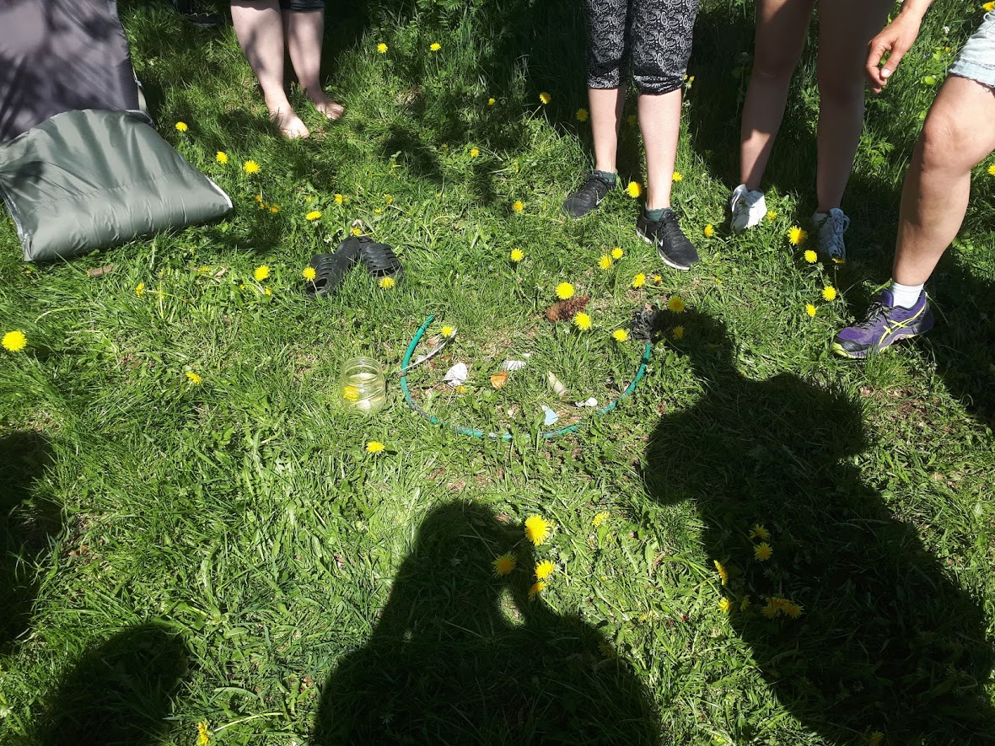

Short description of the ecology of a beach:

How/why does it differ from a freshwater lake/forest/dry land/open ocean??
It differs in the way that the variation is huge, as the beach area often differs a lot and often may include inputs from forest, dry land and open ocean flora. It does not strictly stick to one specific pattern.

